

BacaSama – A Literacy Learning App for Illiterate Adults in Malaysia

Lee Su Fah

Bachelor of Software Engineering with Honours
2024

BacaSama – A Literacy Learning App for Illiterate Adults in Malaysia

Lee Su Fah

This project is submitted in partial fulfilment of the requirement for the degree of
Bachelor of Software Engineering with Honours

Faculty of Computer Science and Information Technology
UNIVERSITI MALAYSIA SARAWAK
2025

BacaSama – A Literacy Learning App for Illiterate Adults in Malaysia

Lee Su Fah

Projek ini merupakan salah satu keperluan untuk
Ijazah Sarjana Muda Kejuruteraan Perisian dengan Kepujian

Fakulti Sains Komputer dan Teknologi Maklumat
UNIVERSITI MALAYSIA SARAWAK
2025

TABLE OF CONTENTS

TABLE OF CONTENTS i
LIST OF FIGURES iii
LIST OF TABLES v
ABBREVIATIONS vi
ABSTRACT vii
ABSTRAK viii
CHAPTER 1: INTRODUCTION 1
1.1 Introduction 1
1.2 Problem Statement 2
1.3 Scope 4
1.4 Aims and Objectives 5
1.5 Brief Methodology 6
1.6 Significance of Project 7
1.7 Project Schedule 8
1.8 Expected Outcome 8
1.9 Report Outline 8
1.10 Summary 9
CHAPTER 2: LITERATURE REVIEW 11
2.1 Introduction 11
2.2 Existing Efforts / Initiatives 12
2.2.1 Orang Asli Functional Literacy Programme (PLFOA) 12
2.2.2 Literacy Education for Adult Skills (LEADS) and Functional Literacy Programme (PLF) 13
2.2.3 Kelas Dewasa Ibu Bapa Orang Asli dan Peribumi (KEDAP) 14
2.3 Existing Literacy Applications 15
2.3.1 Citizen Literacy 15
2.3.2 Duolingo ABC 18
2.3.3 Khan Academy Kids 20
2.3.4 Comparison Study 22
2.4 Software and Hardware 25
2.4.1 Android Studio 26
2.4.2 Flutter 26
2.4.3 Firebase 27
2.4.4 Figma 27
2.5 Summary 27
CHAPTER 3: REQUIREMENT ANALYSIS AND DESIGN 29
3.1 Introduction 29
3.2 Rapid Application Development (RAD) 29
3.2.1 Requirements Planning 29
3.2.2 System Requirements 42
3.2.3 Functional Requirements 44
3.2.4 Non- Functional Requirements 44
3.2.5 Accessibility Features 44
3.2.6 Culture Considerations 45
3.3 System Design 45
3.3.1 Overview 45
3.3.2 Use Case Diagram 46
3.3.3 Use Case Description 47
3.3.3 Sequence Diagram 52
3.3.4 Class Diagram 55
3.3.5 State Diagram 56
3.3.6 Component Diagram 56
3.3.7 Interface Design 56
3.3.8 Technical Architecture 60
3.3.9 Security Features 60
3.4 Summary 61
REFERENCES 62
APPENDICES 65
Appendix A: Project Schedule 65
Appendix B: Project Schedule 67
Appendix C: Survey Questionnaire 68
Appendix D: Component Diagram 73

LIST OF FIGURES
Figure 1: Literacy and Numeracy rates in Malaysia between 2016 and 2020 for 15 years old and over (UNICEF Malaysia, 2023) 2
Figure 2: Basmi buta huruf di Kawasan Pedalaman Negeri in – Harden (Harian Sarawak, 2024) 3
Figure 3: Rapid Application Development (Plutora, 2019) 6
Figure 4: Collaboration JAKOA and KEMAS on Literacy Program (Ibrahim, 2020) 13
Figure 5: LEADS Program (Utusan Borneo Online, 2020) 14
Figure 6: Graduation Ceremony for KEDAP in Kota Kinabalu, Sabah (Sabah Media, 2023) 15
Figure 7: Learning Unit Screen for Citizen Literacy 16
Figure 8: Learning Unit Screen for Duolingo ABC 18
Figure 2.9: Learning Unit Screen for Khan Academy Kids 21
Figure 10: Android Studio Logo 26
Figure 11: Flutter Logo 26
Figure 12: Firebase Logo 27
Figure 13: Figma Logo 27
Figure 14: Pie Chart of Respondents’ Age Group 31
Figure 15: Pie Chart of Respondents’ Gender 32
Figure 16: Pie Chart of Respondents’ Occupation 33
Figure 17: Pie Chart of Respondents’ Location 33
Figure 18: Pie Chart of Respondents’ Primary Language Spoken 34
Figure 19: Pie Chart of Respondents’ Highest Education 34
Figure 20: Pie Chart of Respondents’ Malay Literacy 35
Figure 21: Bar Chart of Respondents’ Challenges in Improving Literacy 35
Figure 22: Pie Chart of Respondents’ Participation in Literacy Program 36
Figure 23: Pie Chart of Respondents’ Smartphone Ownership 36
Figure 24: Pie Chart of Respondents’ Frequently of Smartphone Usage 37
Figure 25: Bar Chart of Respondents’ Familiarity with Mobile Apps 37
Figure 26: Pie Chart of Respondents’ Experience with Educational Apps 38
Figure 27: Bar Chart of Respondents’ Preferred Learning Methods 38
Figure 28: Bar Chart of Respondents’ Encouragement Sources 39
Figure 29: Bar Chart of Respondents’ Motivational Factors 40
Figure 30: Pie Chart of Respondents’ Preferred App Interface 40
Figure 31: Pie Chart of Respondents’ Navigation Preference 41
Figure 32: Pie Chart of Respondents’ Language Preference 41
Figure 33: Pie Chart of Respondents’ Visual Style Preference 42
Figure 34: Bar Chart of Importance of Voice Guidance for Respondents 42
Figure 35: Use Case Diagram for BacaSama 46
Figure 36: Sequence Diagram for User Registration/ Login 53
Figure 37: Sequence Diagram for Starting and Completing Lesson 53
Figure 38: Sequence Diagram for Attempting Quiz and Receiving Feedback 54
Figure 39: Sequence Diagram for Viewing Progress and Earning Reward 54
Figure 40: Class Diagram for BacaSama 55
Figure 41: State Diagram for BacaSama 56
Figure 42: Login Screen for BacaSama 57
Figure 43: Dashboard Screen for BacaSama 58
Figure 44: Lesson’s Preview Screen for BacaSama 59
Figure 45: Lesson with Exercise for BacaSama 60
Figure 46: Gantt Chart for Project Schedule FYP 1 and FYP 2 67
Figure 47: Component Diagram for BacaSama 73

LIST OF TABLES
Table 1: Features Offered by Citizen Literacy 16
Table 2: Advantages and Disadvantages of Citizen Literacy 17
Table 3: Features Offered by Duolingo ABC 19
Table 4: Advantages and Disadvantages of Duolingo ABC 20
Table 5: Features Offered by Khan Academy Kids 21
Table 6: Advantages and Disadvantages of Khan Academy Kids 22
Table 7: Comparison on Citizen Literacy App, Duolingo ABC and Khan Academy Kids 23
Table 8:Device Specification and Description 43
Table 9: Software and Description 43
Table 10: Use Case Description for Register/Login 47
Table 11: Use Case Description for Starting a Lesson 48
Table 12: Use Case Description for Completing a Lesson 49
Table 13: Use Case Description for Attempting Quiz 49
Table 14: Use Case Description for Receiving Feedback 50
Table 15: Use Case Description for Tracking Progress 50
Table 16: Use Case Description for Earning Rewards 51
Table 17: Use Case Description for Using Voice Guidance 51
Table 18: Use Case Description for Exiting Application 52
Table 19: Project Schedule for FYP 1 and FYP 2 65

ABBREVIATIONS
AI | Artificial Intelligence
IDE | Integrated Development Environment
IT | Information Technology
JAKOA | Jabatan Kemajuan Orang Asli
KEMAS | Jabatan Kemajuan Masyarakat
LEADS | Literacy Education for Adult Skills
PLF | Program Literasi Fungsian
PLFOA | Program Literasi Fungsian Orang Asli
RAD | Rapid Application Development
SDG | Sustainable Development Goals
UI | User Interface
UNESCO | United Nations Educational, Scientific and Cultural Organization
UNICEF | United Nations Children's Emergency Fund
UX | User Experience

ABSTRACT

BacaSama is a mobile application designed to address the literacy challenges faced by illiterate adults in rural Sarawak. The app provides interactive lessons in the Malay language, focusing on reading and writing skills. Using a user-friendly interface, gamified features, and offline accessibility, the application ensures engagement and adaptability for users with limited digital experience. Developed using Flutter, Firebase, and Figma, BacaSama leverages advanced technologies such as speech recognition and real-time data storage to track progress and provide personalized learning experiences. By empowering adults with essential literacy skills, the app contributes to improving socio-economic opportunities, reducing inequalities, and aligning with Sustainable Development Goals, particularly SDG-4 (Quality Education). The project also emphasizes cultural relevance and usability for the target audience, ensuring it becomes an effective tool in bridging literacy gaps in rural communities.

ABSTRAK

BacaSama ialah aplikasi mudah alih yang direka untuk menangani cabaran literasi yang dihadapi oleh golongan dewasa buta huruf di kawasan luar bandar Sarawak. Aplikasi ini menyediakan pelajaran interaktif dalam Bahasa Melayu dengan penekanan kepada kemahiran membaca dan menulis. Dengan antara muka mesra pengguna, ciri gamifikasi, dan kebolehcapaian luar talian, aplikasi ini memastikan penglibatan dan kebolehsuaian bagi pengguna yang kurang pengalaman digital. Dibangunkan menggunakan Flutter, Firebase, dan Figma, BacaSama memanfaatkan teknologi canggih seperti pengecaman suara dan penyimpanan data masa nyata untuk menjejaki kemajuan serta menyediakan pengalaman pembelajaran yang diperibadikan. Dengan memberi kuasa kepada golongan dewasa dengan kemahiran literasi asas, aplikasi ini menyumbang kepada peningkatan peluang sosio-ekonomi, mengurangkan ketidaksamaan, dan selaras dengan Matlamat Pembangunan Mampan, khususnya SDG-4 (Pendidikan Berkualiti). Projek ini juga menekankan kepentingan budaya dan kebolehgunaan untuk kumpulan sasaran, menjadikannya alat yang berkesan dalam merapatkan jurang literasi dalam komuniti luar bandar.

CHAPTER 1: INTRODUCTION

1.1 Introduction
BacaSama is a mobile application developed specifically to provide a lifeline to illiterate adults in Sarawak, helping them learn fundamental reading and writing skills in the Malay language. Literacy, as defined by UNESCO, encompasses the ability to identify, understand, interpret, create, and communicate using written and printed materials. In the Malaysian context, adults are generally defined as individuals aged 18 years and above, who are recognized by law as having full legal capacity and responsibility (Government of Malaysia, 1971). Many of these adults, especially in rural and remote areas of Sarawak, face significant barriers to accessing formal education due to the lack of infrastructure and resources, leaving them without the opportunity to acquire basic literacy skills.
BacaSama focuses specifically on teaching reading and writing because these skills form the foundation for functional literacy, enabling individuals to understand essential information, engage with educational content, and participate more fully in society. Literacy is a critical gateway to personal and professional development, and for many adults in rural Sarawak, it represents the first step toward breaking the cycle of poverty and improving quality of life. Unlike numerical or digital skills, which often require literacy as a prerequisite, reading and writing skills are fundamental and universally necessary for accessing broader learning opportunities and navigating everyday life.
BacaSama aligns closely with the United Nations’ Sustainable Development Goal 4 (SDG-4): Quality Education, which emphasizes ensuring inclusive and equitable quality education and promoting lifelong learning opportunities for all. By targeting marginalized communities in Sarawak, the app addresses SDG-4’s call to eliminate disparities in access to education, particularly for vulnerable populations such as rural and indigenous communities. Through its user-friendly, culturally relevant, and offline-capable platform, BacaSama empowers adult learners to overcome literacy challenges, fostering their ability to engage with societal opportunities and improve their socioeconomic status.
Ultimately, BacaSama is more than a tool for learning to read and write; it is a bridge to greater inclusion, independence, and self-reliance for the people of Sarawak. By focusing on literacy, the app lays a crucial foundation for lifelong learning and supports national and global efforts to achieve education for all.

1.2 Problem Statement
UNICEF Malaysia (2023) stated that, literacy rate in 2020 for youth and adults of 15 years old and over in Malaysia is 96.3% as shown in Figure 1 below.
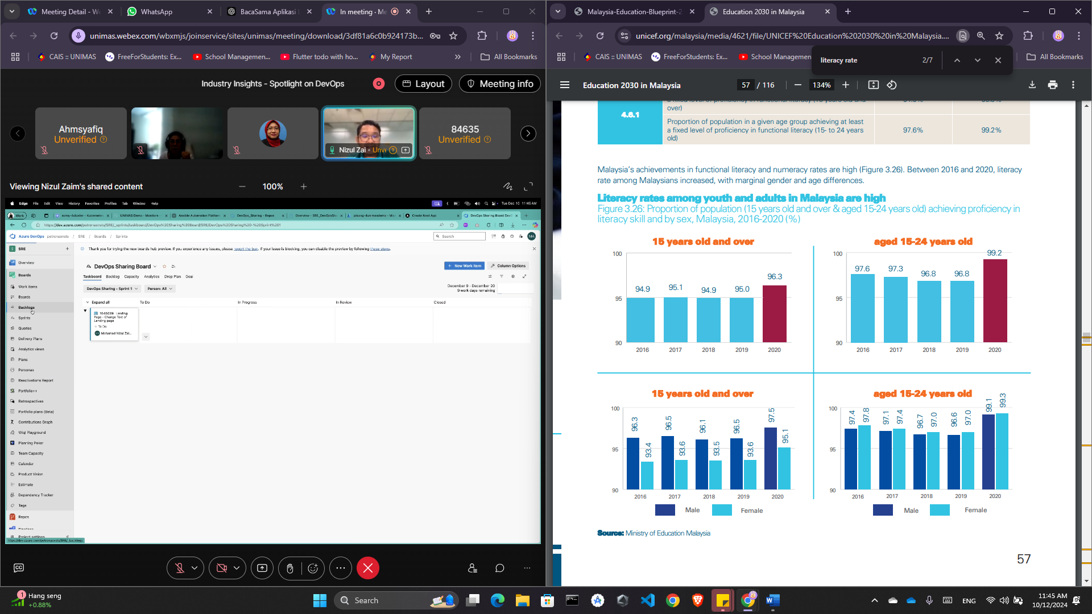
Figure 1: Literacy and Numeracy rates in Malaysia between 2016 and 2020 for 15 years old and over (UNICEF Malaysia, 2023)
Despite the high literacy rate over the year, a significant number of adults, particularly in rural areas and older demographics, still struggle with basic literacy skills. Many of these individuals missed out on formal schooling and have limited opportunities for "second chance" education, preventing them from fully participating in society. In Sarawak, rural areas face additional challenges, such as limited infrastructure and access to trained educators, which further exacerbates low literacy rates (UNICEF Malaysia, 2023). To address this issue, programs like Literacy Education for Adult Skills (LEADS), under the Department of Community Development (KEMAS), have been introduced to provide adult literacy education in rural areas.
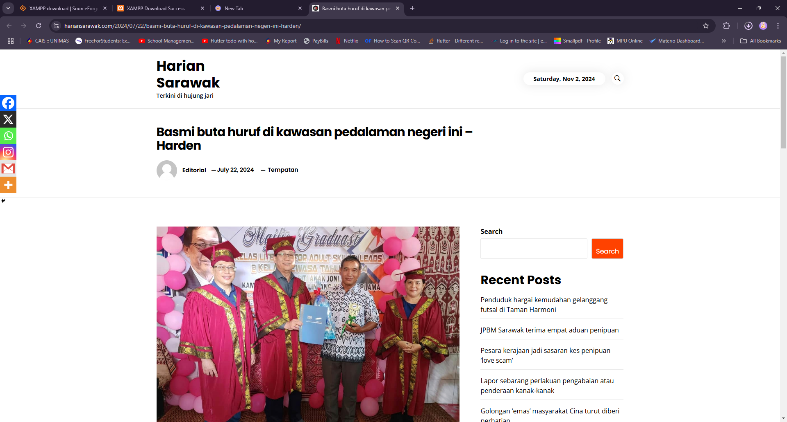
Figure 2: Basmi buta huruf di Kawasan Pedalaman Negeri in – Harden (Harian Sarawak, 2024)
These initiatives have seen some success in reducing illiteracy, Figure 1 above shows the recent graduation of participants from a LEADS program in Sri Aman. However, for the program to truly make a lasting impact, it is crucial that graduates continue their learning journey beyond basic literacy. Continued access to education and opportunities for improvement will help them further develop literacy skills and enable them to better engage in daily tasks and interactions with government offices (Harian Sarawak, 2024). Programs like LEADS offer a valuable foundation, but ongoing support and resources are necessary to ensure long-term progress for adult learners.
In addition to these challenges, illiterate adults face significant barriers in adapting to modern communication and technological advancement. Many are confined to using voice chat on messaging platforms, unable to utilize text-based communication tools due to their inability to read or write. They also struggled to navigate digital applications, as written instructions, icons, and features are incomprehensible to them. This disconnect limits their access to essential services, their ability to stay updated with news – which is predominantly written – and their engagement with digital society.
These challenges highlight the need for solutions like BacaSama, a mobile application designed to provide continuous literacy education for adults in rural Sarawak. By equipping users with foundational reading and writing skills in Malay, BacaSama not only complements existing programs like LEADS but also addresses the pressing need for tools that bridge the gap between literacy and digital engagement. Such solutions are essential for empowering individuals to actively participate in their communities, access services, and adapt to an increasingly digital world.

1.3 Scope
The proposed application for the BacaSama project has a focused scope, targeting adults in rural Sarawak who lack basic literacy skills. Its primary geographic reach will encompass underserved areas across Sarawak, particularly those with infrastructural challenges that hinder access to formal education. The app's design will cater specifically to the learning needs of non-literate adults, with localized content in the Malay language to ensure it resonates with the cultural and linguistic context of Sarawak.
The key features of BacaSama will include interactive, voice-guided lessons that can aid users in developing reading and writing skills, complemented by exercises that reinforce learning. The app will also offer AI-powered speech recognition to provide real-time feedback on their pronunciation. A major part of the application's user interface will involve gamification elements, such as badges and rewards, to engage and motivate users. This will be further enhanced by offline functionality, allowing learning to continue even in areas with limited internet connectivity.
The primary users of the application will be adults in rural communities, but secondary users might include the family members who assist in the learning process. Initially, the app will be developed for Android, given the platform's wide accessibility. This scope ensures the app is a practical tool for adult literacy, helping to bridge educational gaps in Sarawak and improving users' socio-economic prospects.

1.4 Aims and Objectives
The project's aim is to develop a mobile application that improves literacy among illiterate adults in rural Sarawak by focusing on tailored learning modules, offline accessibility, and user engagement through gamification.
- To study and analyze existing literacy applications
The primary objective involves evaluating current mobile literacy applications to identify effective features, learning approaches, and limitations that can inform the design of BacaSama.
- To design and develop a culturally relevant literacy application for adults in Sarawak
This objective focuses on creating a mobile app tailored to literacy needs of adult learners, emphasizing the Malay language, offline accessibility, and gamified engagement.
- To test and evaluate the usability and functionality of BacaSama
This objective ensures that the application is usable and effective through user testing with the target audience and functionality assessments to ensure it meets its educational goals.

1.5 Brief Methodology
For the development of the BacaSama, the project will use the Rapid Application Development (RAD). RAD is a fast-paced software development methodology focused on quick prototyping and iterative development.
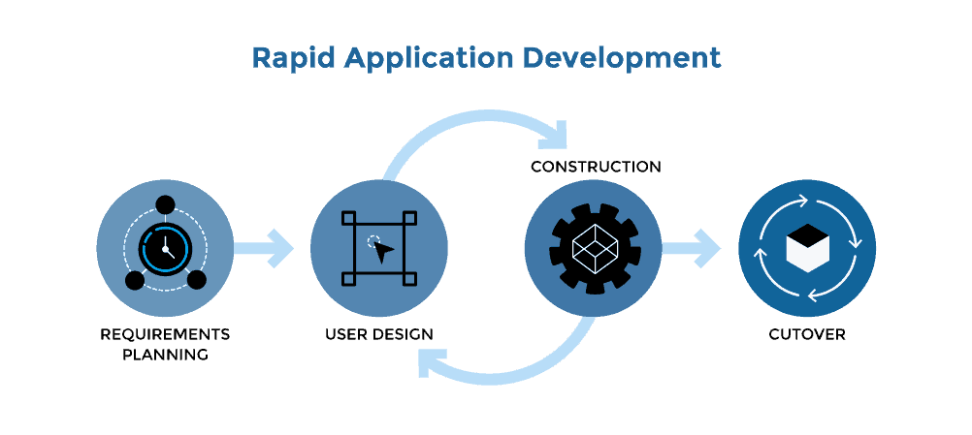
Figure 3: Rapid Application Development (Plutora, 2019)
RAD's flexibility allows for adjustments based on user feedback throughout the development process, ensuring that the final product effectively addresses the literacy needs of its target audience. This method not only accelerates development but also encourages user engagement and satisfaction. The RAD approach involves several key steps:
- Requirements Planning: Gather initial requirements by engaging with users to understand their literacy needs and challenges.
- User Design: Involve users in the design process through feedback sessions, ensuring the app's interface and features are user-friendly and culturally appropriate.
- Construction: Develop prototypes quickly, incorporating essential features like audio lessons and interactive elements based on user input.
- Cutover: Deploy the app to users and gather ongoing feedback for continuous improvements, creating a cycle of enhancement based on real user experiences.

1.6 Significance of Project
The BacaSama mobile application addresses the significant challenges faced by illiterate adults in rural Sarawak. BacaSama aims to bridge this gap by offering a user-friendly platform to teach basic reading and writing skills in Malay. By equipping users with the ability to read, write, and navigate digital tools, the app enables them to communicate effectively, understand instructions, and engage with written content, both online and offline.
By addressing these limitations, BacaSama promotes social inclusion and digital literacy, allowing users to actively participate in their communities and improve their quality of life. Furthermore, the BacaSama initiative contributes to SDG 4 (Quality Education) by providing an inclusive learning platform that addresses educational disparities, especially in rural areas with limited access to formal education. The project leverages technology to ensure that those who have missed out on formal schooling can still acquire literacy skills, fostering empowerment and reducing inequalities.
Additionally, the project aligns with SDG 1 (No Poverty) by enabling illiterate adults to gain essential literacy skills, which are crucial for improving their livelihoods and breaking the cycle of poverty. By enhancing their ability to read, write, and use digital platforms, BacaSama helps users access better job opportunities, financial resources, and social services, contributing to poverty reduction in rural communities.
The app also contributes to SDG 8 (Decent Work and Economic Growth). Through improved literacy, users can engage more effectively in the workforce, acquire new skills, and increase their economic productivity, ultimately contributing to the overall economic growth of the region. In this way, BacaSama is not just an educational tool, but a key driver of social and economic development, helping users gain independence, improve their livelihoods, and foster long-term community growth.

1.7 Project Schedule
Throughout year of study, this project is divided into two parts: Final Year Project 1 (FYP 1) and Final Year Project 2 (FYP 2). FYP 1 must be completed between 10 October 2024 (Week 1) and 12 January 2025 (Week 13), while FYP 2 is expected to be completed during semester 2. The project schedule is as shown in Appendix A and the Gantt Chart is as shown in Appendix B.

1.8 Expected Outcome
The expected outcome for the proposed application, BacaSama, includes the development of a fully functional app that provides interactive lessons and assessments in Malay, targeting illiterate adults. The application aims to achieve measurable improvements in literacy, which will be assessed through in-app quizzes that evaluate reading fluency and writing accuracy. The app will offer both offline and online functionality, ensuring accessibility for users in rural areas with limited internet connectivity. To enhance user engagement, gamified features such as progress tracking, rewards, and badges will be integrated, motivating users to complete literacy lessons and maintain their learning journey. Overall, these outcomes are designed to empower illiterate adults, providing them with essential literacy skills and stimulating a greater sense of community involvement.

1.9 Report Outline
This report is structured to provide a comprehensive overview and analysis of the development of the BacaSama mobile application, which aims to improve literacy among adults in rural Sarawak. The following chapters outline the key aspects of the project:
Chapter 1 introduces the background, problem statement, and objectives of the project, focusing on the barriers to literacy in remote areas and the application’s potential to mitigate these issues.
Chapter 2 will cover a literature review, comparing relevant studies and previous projects related to adult literacy and mobile app design tailored for low-literacy adults. This review will guide the objectives and highlight unique aspects of BacaSama that address specific needs in Sarawak’s rural communities.
Chapter 3 presents the methodology, detailing the design and requirement analysis process, including the selection of target user needs and the inclusion of accessible, culturally appropriate UI/UX features.
Chapter 4, the implementation phase will be discussed, including the development process, technology stack, and the core functionalities of the application, such as offline capabilities and voice assistance.
Chapter 5 outlines the testing methods, feedback collection from target users, and an evaluation of the app’s effectiveness. The chapter also includes an evaluation of the app’s performance based on predefined success criteria, identifying areas for improvement and lessons learned during the testing process.
Finally, Chapter 6 concludes the report, summarizing findings, evaluating the project's success, and proposing potential future improvements. This section aims to set the stage for the ongoing development and scalability of BacaSama.

1.10 Summary
Chapter 1 introduces the BacaSama mobile application, designed to tackle the persistent issue of low literacy rates among adults in rural Sarawak. By providing accessible and user-friendly literacy education in the Malay language, the application aims to address critical challenges such as limited educational infrastructure, lack of formal schooling opportunities, and barriers to digital literacy. This chapter outlines the background of the literacy problem, identifies its root causes through a detailed problem statement, and establishes clear objectives for the project.
Additionally, it highlights the broader significance of addressing literacy gaps, emphasizing how improved literacy can enhance individuals' socioeconomic opportunities, empower them to engage in digital society, and contribute to national goals and global Sustainable Development Goals (SDGs), particularly SDG-1 (No Poverty), SDG-4 (Quality Education), and SDG-8 (Decent Work and Economic Growth).
By setting a strong foundation, Chapter 1 paves the way for the following chapters, which will explore the design, development, testing, and evaluation of a tailored solution aimed at empowering underserved communities and fostering lifelong learning.

CHAPTER 2: LITERATURE REVIEW

2.1 Introduction
Literacy is a fundamental skill for social and economic participation, yet illiteracy persists among adults in many parts of Malaysia, particularly in rural areas of Sarawak and Sabah. While numerous educational applications have been developed globally to address literacy issues, most are designed for children or young learners, leaving a significant gap in resources for adult learners. This chapter reviews existing educational applications, including Citizen Literacy (United Kingdom), Duolingo ABC (United States), and Khan Academy Kids (United States) examining their features, processes, target users, and regional focus. In Malaysia, no prominent literacy application specifically targets adult learners. The reviewed applications cater to different demographics and serve both local and global audiences:
- Citizen Literacy: Designed for adult learners, it offers functional literacy tools and multimedia lessons, primarily catering to English speakers globally.
- Duolingo ABC: Targeted at young learners, it gamifies foundational literacy skills. Although designed for children, it is widely accessible to global audiences.
- Khan Academy Kids: Aimed at children, it provides comprehensive educational content, including literacy, numeracy, and critical thinking, with global reach.
This comparative analysis identifies strengths and limitations of these applications, which inform the development of BacaSama, a localized literacy app for adults in rural Sarawak. BacaSama seeks to bridge the gaps in existing efforts by offering culturally relevant, accessible, and offline-capable tools for underserved adult learners in Malaysia.

2.2 Existing Efforts / Initiatives
Malaysia has implemented various policies and programs to eradicate illiteracy, with a particular focus on rural areas and marginalized communities. These initiatives have laid the groundwork for addressing literacy challenges.

2.2.1 Orang Asli Functional Literacy Programme (PLFOA)
The Orang Asli Functional Literacy Programme (PLFOA) is a focused initiative aimed at eradicating illiteracy among the Orang Asli community, particularly in rural and remote areas of Peninsular Malaysia. Launched to improve the quality of life for the Orang Asli population, the program emphasizes the "3M" approach—Membaca (Reading), Menulis (Writing), and Mengira (Arithmetic)—to equip participants with essential skills for daily life and self-sufficiency (Adminit, 2022). Targeting adults, youth, and school dropouts, PLFOA provides a culturally sensitive education model that aligns with the unique needs and traditions of the Orang Asli community. The program has made measurable progress in improving literacy rates among participants. Implemented by JAKOA and Kemas, PLFOA integrates culturally relevant teaching methods, enhancing quality of life and promoting education's importance. Since 2019, it has benefited 200 Orang Asli, with RM40,000 allocated annually for program expansion in Kelantan (Yahya, 2023).
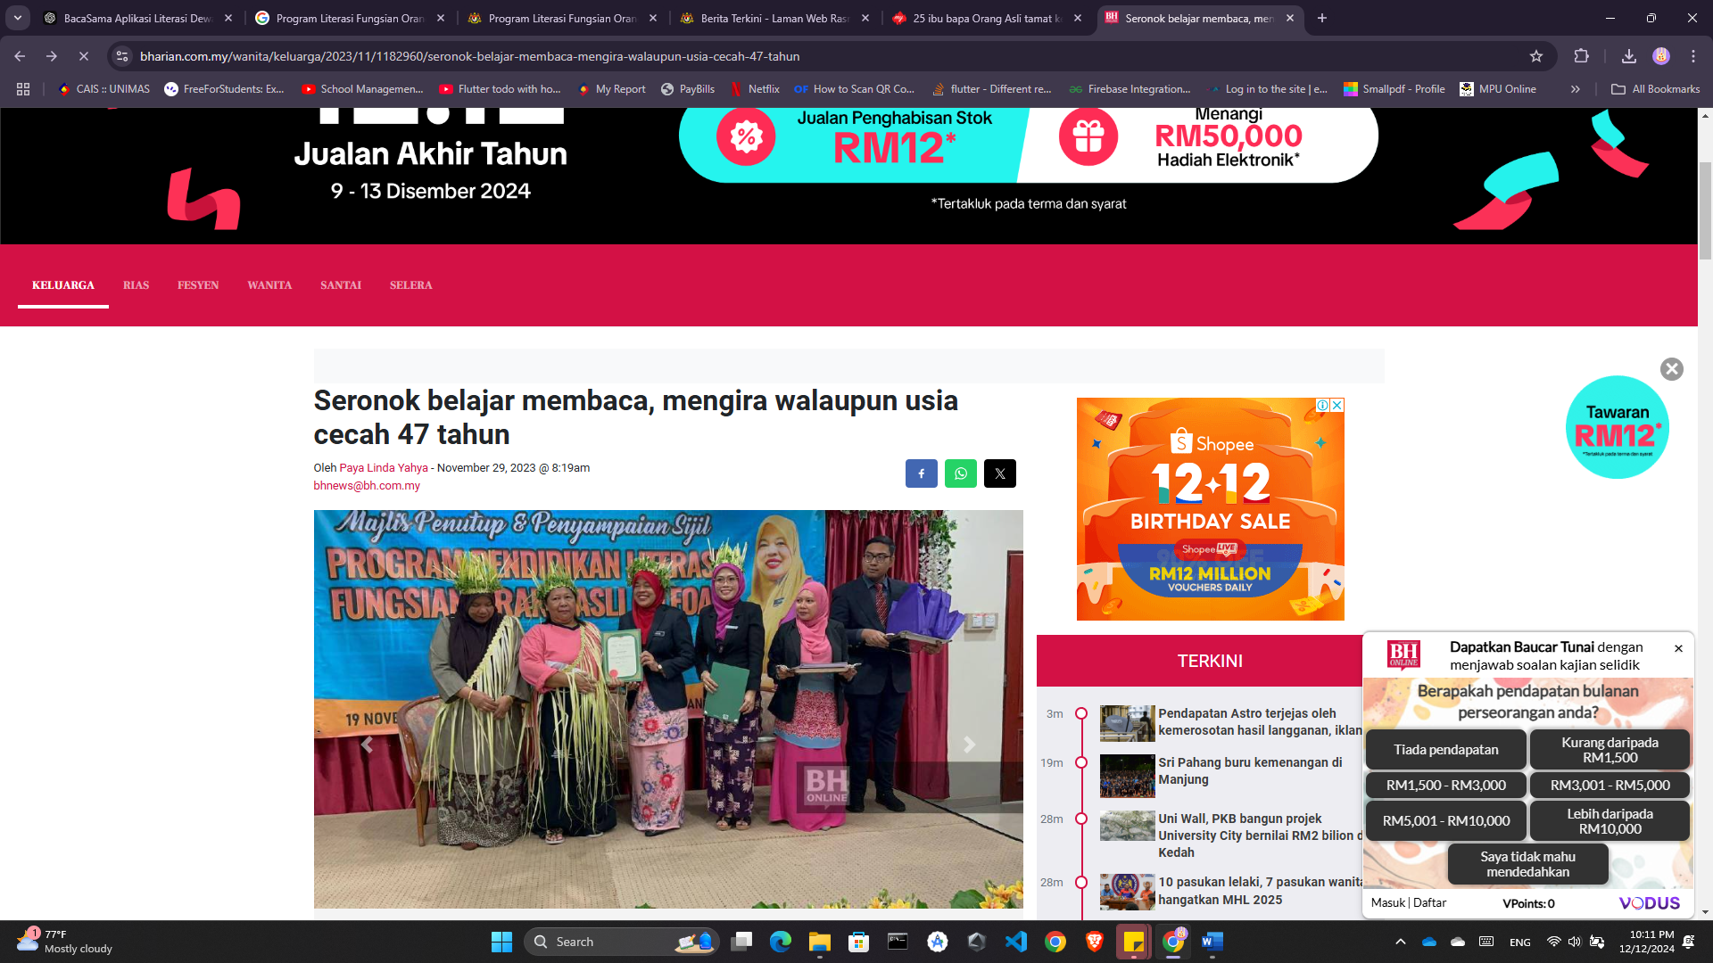
Figure 4: Collaboration JAKOA and KEMAS on Literacy Program (Ibrahim, 2020)

2.2.2 Literacy Education for Adult Skills (LEADS) and Functional Literacy Programme (PLF)
The Literacy Education for Adult Skills (LEADS) and Functional Literacy Programme (PLF) are initiatives by Jabatan Kemajuan Masyarakat (KEMAS) under Malaysia’s Ministry of Rural and Regional Development. These programs aim to eradicate illiteracy and enhance the quality of life for rural and marginalized communities, particularly in the remote areas of Sabah and Sarawak (Portal Rasmi Jabatan Kemajuan Masyarakat, n.d). The program has expanded their scope by introducing Information Technology (IT) literacy, such as using communication tools like WhatsApp, to adapt to the growing digitalization of society said Abduraya, KEMAS Officer, Sibu Division (Utusan Borneo Online, 2020). The program aims to ensure that issues of illiteracy do not persist, even among those who are older adults or grandparents (Lambai, 2023). This highlights the transformative potential of these literacy initiatives in promoting lifelong learning. Through these efforts, KEMAS continues to support Malaysia’s national goal of improving literacy rates and fostering inclusive education for all.
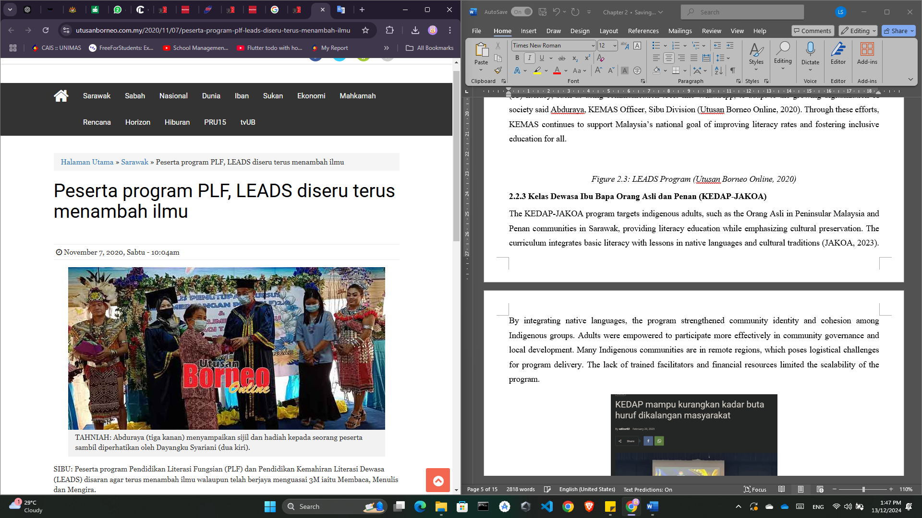
Figure 5: LEADS Program (Utusan Borneo Online, 2020)

2.2.3 Kelas Dewasa Ibu Bapa Orang Asli dan Peribumi (KEDAP)
The KEDAP program targets indigenous adults, such as the Orang Asli, Penan communities in Sabah, providing literacy education while emphasizing cultural preservation as shown in the Figure 2.3 below is one of the programs held by KEDAP in Kota Kinabalu Sabah. According to Sabah Media (2023), the program not only aims to enhance literacy skills but also contributes to combating extreme poverty through education. KEDAP also fosters a heightened awareness of the importance of education among participants. As noted by Abidin Marjan, Deputy Director of the Sabah State Education Department, this initiative helps parents play a more active role in their children's academic journey, positively impacting both literacy and school attendance rates.
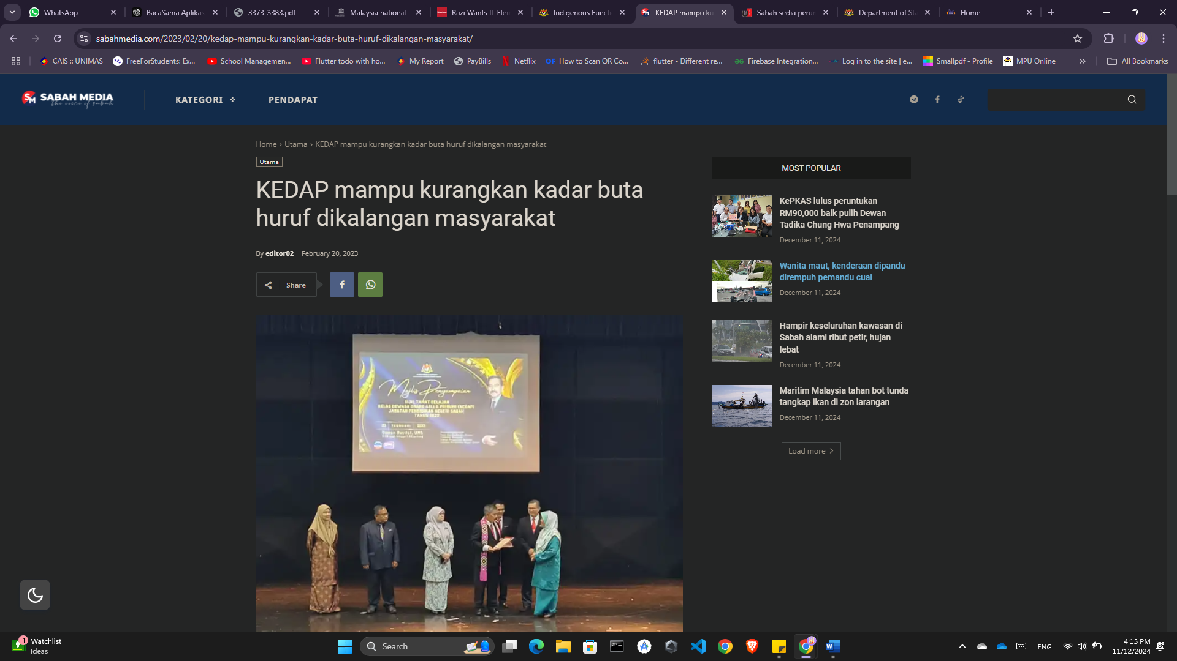
Figure 6: Graduation Ceremony for KEDAP in Kota Kinabalu, Sabah (Sabah Media, 2023)

2.3 Existing Literacy Applications
This section reviews existing mobile literacy applications that provide innovative solutions to literacy challenges. These apps offer flexibility, interactivity, and scalability to enhance literacy levels among diverse target audiences. Each subsection details the features, processes, advantages, and disadvantages of the applications and compares them to the proposed application, BacaSama, which targets adult learners in rural Sarawak.

2.3.1 Citizen Literacy
Citizen Literacy is an app designed for adults who struggle with reading and writing skills, particularly those at the lowest literacy levels. Developed by Citizen Literacy CIC in the UK, the app uses a phonics-based approach, helping users understand the relationships between sounds and letters, improving foundational literacy skills as shown in Figure 2.1. Recognizing the unique challenges faced by adult learners, Citizen Literacy also emphasizes contextual learning, incorporating real-world scenarios to make literacy skills immediately relevant to users' daily lives. This approach helps address barriers that low-literate adults often face in traditional learning environments, offering a more accessible and practical pathway to literacy (Casey, 2023). However, the Citizen Literacy team has primarily emphasized the development of a "web app" that works like a native app but is hosted online.
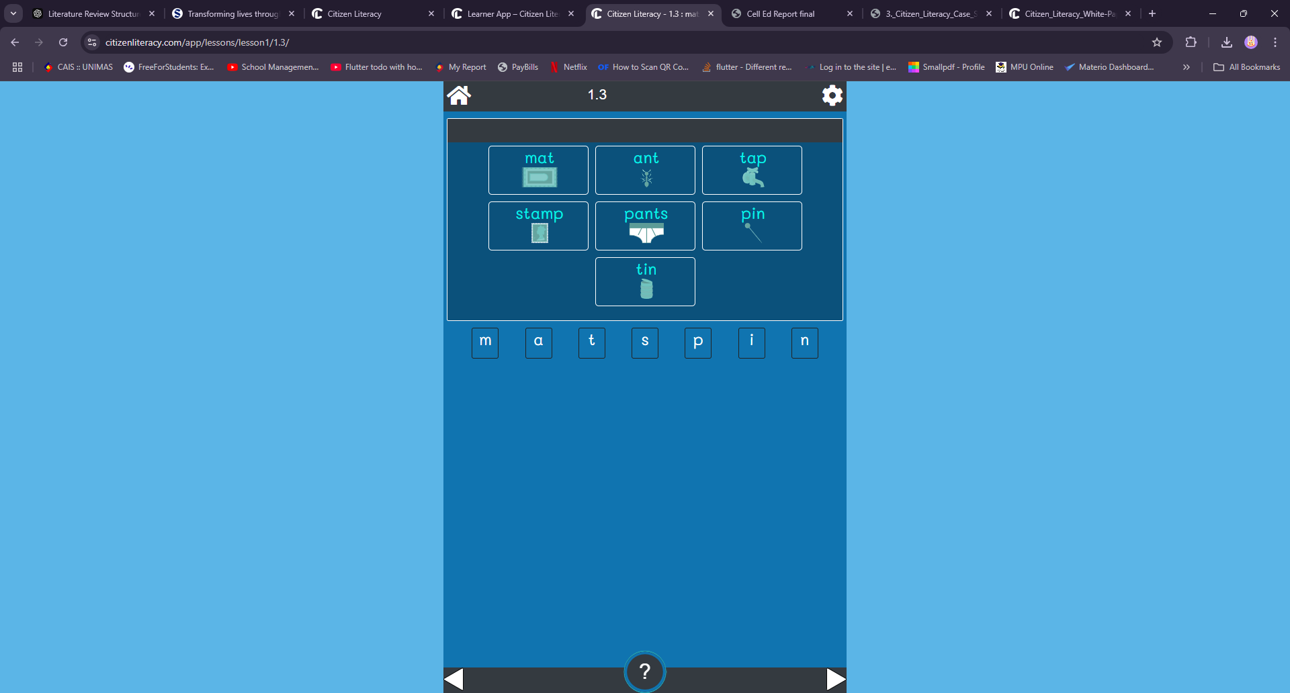
Figure 7: Learning Unit Screen for Citizen Literacy
Source: https://citizenliteracy.com/app/

2.3.1.1 Features
Citizen Literacy offers features designed to support foundational literacy learning for adults. These features address the unique challenges faced by low-literate adults and include phonics-based lessons, speech recognition, interactive exercises, progress tracking, and offline functionality.
Table 1: Features Offered by Citizen Literacy
Features | Description
Phonics-based lessons | Introduces phonics to help users understand letter-sound relationships.
Speech recognition | Provides feedback on pronunciation, enabling users to self-correct.
Interactive exercises | Engages users with quizzes and hands-on activities to reinforce learning.
Progress tracking | Tracks user progress across lessons, helping learners monitor their growth.

2.3.1.2 Process
The app follows a structured process to help learners progress from basic to advanced literacy skills through interactive modules:
- Users sign up and complete an initial assessment to gauge their reading level.
- They are guided through phonics-based lessons, focusing on sound-letter recognition.
- Interactive exercises follow each lesson, allowing users to practice skills in reading and pronunciation.
- Speech recognition gives real-time feedback on pronunciation accuracy.
- Progress is tracked, and users can revisit lessons as needed.

2.3.1.3 Advantages/Disadvantages
Citizen Literacy’s focus on phonics and real-world scenarios makes it effective for beginner readers. However, it has limitations in addressing advanced literacy needs and diverse cultural contexts.
Table 2: Advantages and Disadvantages of Citizen Literacy
Advantages | Disadvantages
Phonics-based learning is effective for beginner readers. | Limited to basic literacy, lacks advanced topics.
Real-time feedback through speech recognition. | Not optimized for diverse dialects beyond UK English.
Offline access aids users in areas with low connectivity. | User interface may feel outdated or less engaging.

2.3.2 Duolingo ABC
Duolingo ABC is an educational app developed by Duolingo, specifically designed to teach children fundamental reading and writing skills in English (Lavigne, 2022). The app uses gamified learning techniques with a focus on phonics, vocabulary, and early literacy concepts as shown in Figure 2.2 above. With its child-friendly design, Duolingo ABC aims to make learning to read fun and accessible, providing interactive lessons that build foundational literacy skills step-by-step. Although Duolingo ABC is targeted primarily at children, the app is designed to be accessible to a global audience. It is available in multiple languages and can be used by learners worldwide, offering an inclusive educational experience. This global availability ensures that children from various cultural backgrounds and language environments can benefit from the app’s resources.
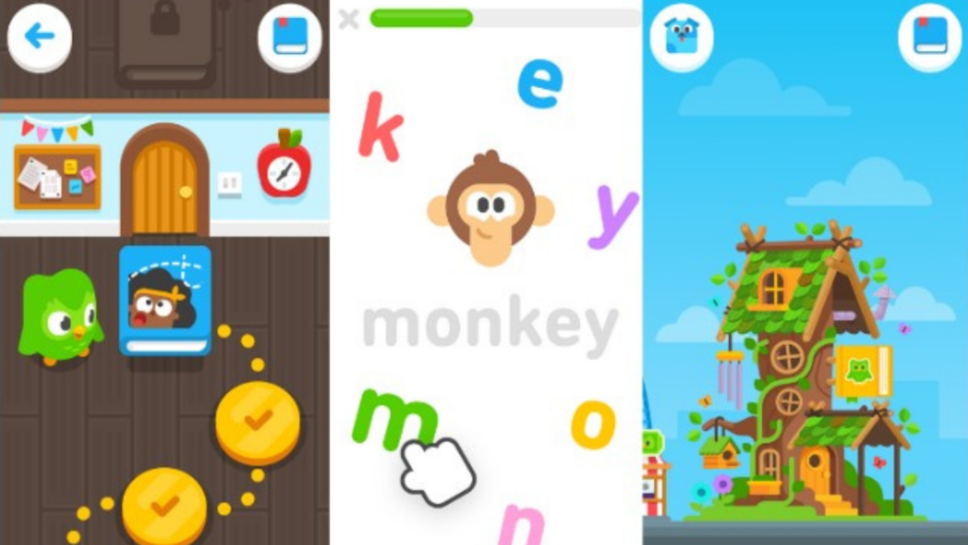
Figure 8: Learning Unit Screen for Duolingo ABC
Source: https://play.google.com/store/search?q=duolingo+abc&c=apps

2.3.2.1 Features
The app incorporates gamification to make learning enjoyable for children. Features include phonics-based games, interactive exercises, personalized feedback, offline functionality, and progress tracking.
Table 3: Features Offered by Duolingo ABC
Features | Description
Phonics and vocabulary | Builds early reading skills through phonics and vocabulary games.
Interactive games | Uses gamified exercises to maintain engagement and reinforce learning.
Personalized feedback | Provides hints and suggestions, helping users progress at their own pace.
Offline functionality | Offers offline access to most lessons, supporting continuous learning without internet.
Progress tracking | Monitors user progress, encouraging self-paced improvement.

2.3.2.2 Process
Duolingo ABC’s process is designed to create a fun, step-by-step learning experience:
- Users sign up and select their learning preferences.
- They are introduced to phonics-based games and exercises.
- Each lesson includes interactive games to reinforce phonics and vocabulary.
- Feedback is provided in real time, assisting users in overcoming mistakes.
- Progress is tracked, and users can advance through increasingly challenging lessons.

2.3.2.3 Advantages/Disadvantages
Duolingo ABC’s gamified approach appeals to children but may not address the needs of adult learners or non-English speakers.
Table 4: Advantages and Disadvantages of Duolingo ABC
Advantages | Disadvantages
Gamified approach keeps users engaged. | Targeted mainly toward children, not optimized for adults.
Interactive exercises enhance learning retention. | Limited language focus, only teaches basic English literacy.
Lessons accessible offline for remote learning. | Limited cultural adaptability, especially for non-English users.

2.3.3 Khan Academy Kids
Khan Academy Kids is an educational app aimed at young children, focusing on foundational skills across reading, writing, math, and critical thinking. This app, which is developed by Khan Academy, incorporates interactive content, drawing tools, and creative activities, supporting a holistic approach to early learning. Figure 2.3 shows one of the activities in the learning unit of Khan Academy Kids. Khan Academy Kids is available for free and is accessible to a global audience. The app offers content in multiple languages, making it widely available to children from diverse linguistic backgrounds. By offering free, high-quality education, Khan Academy Kids is a valuable resource for early childhood education, providing essential learning tools that help children build a strong foundation in critical areas such as literacy, numeracy, and logical thinking (University of Massachusetts Amherst, 2020).

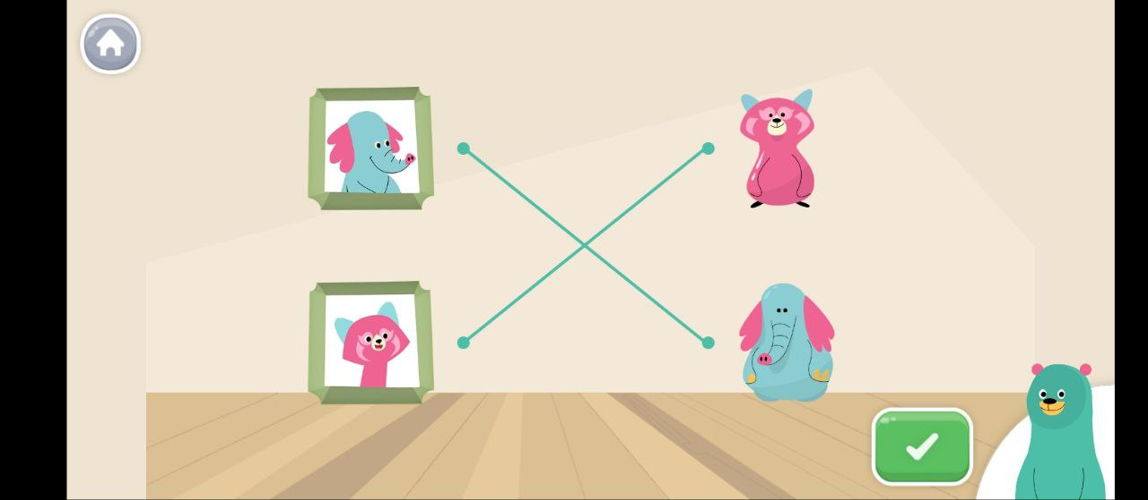
Figure 2.9: Learning Unit Screen for Khan Academy Kids
Source: https://play.google.com/store/search?q=khan+academy+kids&c=apps

2.3.3.1 Features
Khan Academy Kids integrates creative and interactive features to make learning enjoyable. Key features include multimedia content, creative activities, progress tracking, and comprehensive subject coverage.
Table 5: Features Offered by Khan Academy Kids
Features | Description
Comprehensive subjects | It covers a range of subjects, including reading, writing, math, and social-emotional skills.
Interactive lessons | Use animated characters and engaging lessons to keep users interested.
Creative activities | Includes drawing and storytelling activities to foster creativity.
Progress tracking | Monitors user progress and adjusts content based on individual learning speed.
Multimedia content | Offers video and audio content to support diverse learning styles.

2.3.3.2 Process
The app’s process encourages holistic learning:
- Users create a profile to personalize the app experience.
- The app introduces basic literacy concepts using animations and characters.
- Each lesson involves interactive exercises with activities like drawing and storytelling.
- Users receive feedback on tasks, adjusting based on their progress and comprehension.
- Progress tracking is used to adjust lesson difficulty to match the user’s learning pace.

2.3.3.3 Advantages/Disadvantages
Khan Academy Kids’ broad educational scope may appeal to young learners but lacks the targeted literacy focus needed by adult users.
Table 6: Advantages and Disadvantages of Khan Academy Kids
Advantages | Disadvantages
Covers multiple subjects beyond literacy. | Content may feel too child-oriented for adult users.
Encourages creativity and critical thinking. | Limited phonics emphasis, less focus on adult learning needs.
Multimedia resources support various learning styles. | Requires consistent internet access for certain features.

2.3.4 Comparison Study
There are currently no widely recognized mobile literacy applications targeting adult learners in Malaysia. Most initiatives rely on classroom-based programs like PLFOA and LEADS. This has resulted in an underestimated demand for mobile literacy applications tailored for adults, especially in rural areas. Preference for traditional methods due to cultural and generational factors. Limited investment in educational technology for adult learners.
Table 7: Comparison on Citizen Literacy App, Duolingo ABC and Khan Academy Kids
Features | Citizen Literacy App | Duolingo ABC | Khan Academy Kids | BacaSama
Target Audience | Adult learners, primarily those with low literacy in the UK. | Young children, typically ages 3-6, learning English literacy basics. | Young children, typically aged 2-8, with a broader educational focus beyond literacy. | Adults in rural Sarawak.
Language Focus | English phonics and basic literacy. | English literacy, focusing on phonics, vocabulary, and letter recognition. | English literacy, math, and social-emotional learning; limited focus on phonics. | Malay-focused, culturally relevant.
Learning Approach | Phonics-based lessons with speech recognition and interactive exercises. | Gamified learning with interactive exercises, hints, and real-time feedback. | Multi-subject approach with creative activities like drawing and storytelling. | Phonics-based, gamified.
Engagement Strategy | Progress tracking and real-time feedback via speech recognition. | Highly gamified, using rewards, levels, and badges to motivate young users. | Progress tracking, interactive lessons, multimedia, and creative activities. | Gamified quizzes, rewards
Offline Accessibility | Not available offline for the web app | Many lessons are accessible offline, useful for uninterrupted learning for children in low-connectivity areas. | Limited offline access: some features, like multimedia, require internet connectivity. | Most features available offline, which aids users with low connectivity.
Cultural Relevance | Limited to English and UK-based literacy standards. | Primarily U.S.-focused English curriculum, not tailored to diverse cultural contexts. | U.S.-based curriculum, with limited adaptability for non-Western cultural contexts. | Adapted to Sarawak context.
Visual and Interface Design | Simplistic UI, which can feel outdated but is straightforward for adult learners. | Highly colourful and engaging, designed for children’s cognitive needs. | Animated characters and vibrant UI, appealing to young children. | Clear icons, local imagery

BacaSama is an app designed to help adults in rural Sarawak, Malaysia, learn basic reading and writing in Malay. It targets adult learners who have limited or no formal education, particularly in areas with limited educational resources. The app focuses on the Malay language, making the lessons culturally relevant and easy for users to relate to in their daily lives (Ministry of Education Malaysia, 2019). The app uses a phonics-based approach to teach literacy and includes Malay speech recognition to help users practice pronunciation. This is important for non-literate users who may struggle with phonetic accuracy. To keep learners motivated, BacaSama includes gamified features like quizzes, rewards, and progress tracking, making learning fun and encouraging consistent progress. Ryan (2022) states that gamification uses game-like mechanics to increase interest in learning among participants, and this concept has shown high effectiveness.
Since many areas in Sarawak have limited internet access, BacaSama allows users to access lessons offline. This makes the app accessible even in remote areas, aligning with best practices for educational apps designed for low-connectivity environments. The app has a simple, easy-to-use interface with clear icons and local imagery, so adult learners can navigate it without difficulty. BacaSama also includes examples and scenarios based on daily life in Sarawak, such as market interactions and public transport, making learning more relevant to the users' experiences. By combining these features, BacaSama aims to provide an effective and accessible way for adults in rural Sarawak to improve their literacy skills and improve their quality of life.

2.4 Software and Hardware
The development of the proposed use requires several technologies and tools to ensure its performance, dependability, and usage. Every tool is essential to making sure the application is effective, scalable, and user focused.

2.4.1 Android Studio

Figure 10: Android Studio Logo
Android Studio will be the primary Integrated Development Environment (IDE) for building the application. It offers a complete environment that includes code completion, strong debugging tools, and an emulator for testing the app across different Android devices. Android Studio is the best option for developing cross-platform apps because of its compatibility with Flutter. Additionally, its built-in features promote the testing procedure, guaranteeing that the application satisfies quality and performance requirements prior to deployment.

2.4.2 Flutter

Figure 11: Flutter Logo
The primary framework for developing the mobile application will be Flutter. It enables programmers to create a single codebase and publish the application across several operating systems, such as iOS and Android. Flutter may be used to create visually appealing and intuitive user interfaces because of its wide widget library and support for dynamic UI development. Additionally, the framework's hot reload capability speeds up development by allowing developers to view changes instantly.

2.4.3 Firebase

Figure 12: Firebase Logo
The backend solution will be Firebase, which offers crucial features like analytics, real-time database capabilities, and authentication. Firebase Realtime Database facilitates real-time data synchronization, guaranteeing smooth user interactions, while Firebase Authentication will safely handle user login and registration. Furthermore, Firebase Analytics will track user activity and provide insightful data on user performance and engagement.

2.4.4 Figma

Figure 13: Figma Logo
Figma will be used to design the user interface and create prototypes for the application. It makes collaborative UI/UX design possible, guaranteeing that the final product satisfies the requirements of the intended audience, which consists of illiterate individuals living in rural areas. Users with low levels of digital literacy can benefit from layouts that are both aesthetically pleasing and easy to use through Figma's user-friendly design tools.

2.5 Summary
This chapter reviewed three literacy-focused educational applications—Citizen Literacy, Duolingo ABC, and Khan Academy Kids—to explore how different strategies and features address literacy development. Each app offers unique strengths, such as Citizen Literacy's phonics-based lessons and speech recognition tailored for adult learners, Duolingo ABC's engaging gamification for young users, and Khan Academy Kids' holistic, multi-subject approach. However, certain limitations, such as limited cultural adaptability, offline accessibility, and primary focus on young learners rather than adult learners.
The proposed BacaSama application aims to bridge these gaps by delivering a culturally relevant Malay-language literacy tool specifically designed for non-literate adults in rural Sarawak. BacaSama will incorporate a phonics-based approach with Malay speech recognition, tailored offline functionality, and gamification elements to foster motivation and engagement. Its user-friendly interface and culturally resonant content will further enhance accessibility, ensuring that literacy learning is not only achievable but directly applicable to users' daily lives. By addressing the unique needs of adult learners in underserved areas, BacaSama aspires to make a significant impact on literacy rates and socioeconomic inclusion in Sarawak.

CHAPTER 3: REQUIREMENT ANALYSIS AND DESIGN

3.1 Introduction
This chapter outlines the requirements analysis and system design for the BacaSama literacy learning application. It begins with methods used to gather system requirements, lists the functional and non-functional requirements derived from the analysis, and provides a detailed design of the proposed application. The chapter also includes system diagrams and interface design elements to visualize the system architecture and functionality. This ensures that the design aligns with the objectives and addresses the identified challenges.

3.2 Rapid Application Development (RAD)
The BacaSama literacy learning application is being developed using the Rapid Application Development (RAD) methodology. To guarantee that the finished application meets the needs and expectations of the user, RAD places a strong emphasis on iterative development, quick prototyping, and active user interaction. The methodology's emphasis on user feedback, design flexibility, and capacity to produce outcomes more quickly make it ideal for this project. The use of RAD ensures that any changes to the requirements can be quickly integrated into the development process.

3.2.1 Requirements Planning
The RAD methodology's requirements planning phase collects and evaluates system requirements to make sure they are clear and aligned with the project's goals. For the BacaSama project, this phase concentrated on understanding the needs of the target audience, which is adults from rural Sarawak, especially those living in longhouse communities in Niah.

3.2.1.1 Survey-Based Data Collection
A survey-based method was used to determine the needs and preferences of the users. To collect qualitative data, this required distributing questionnaires to possible users and holding casual interviews. The questionnaire is as shown in Appendix C. Key aspects covered in the survey are as follows:
- Common literacy challenges faced by the community.
- User preferences for app features such as offline access and gamification.
- Feedback on usability and cultural relevance of content.

3.2.1.2 Survey Findings
The survey conducted targeted potential users of the BacaSama literacy learning application, focusing on rural communities, particularly adults in longhouses in Niah, Sarawak. The goal of this effort was to get essential details about the target user group's digital requirements, preferences, and literacy challenges. A total of 30 responses were collected, providing an essential foundation for understanding the user requirements and guiding the app's design and features. Various topics were covered in the questionnaire, such as demographic data (age, educational attainment), reading difficulties, competence with technology, and requested app features.
Key obstacles to literacy were identified by the findings, including language preferences, insufficient digital literacy, and restricted access to educational materials. User preferences for features like offline accessibility, gamification elements, and culturally relevant information were also emphasized by the responses. The results are visualized through a series of charts and graphs, which are explained in detail below to provide an in-depth understanding of the data collected.
Figure 14 illustrates the age distribution of respondents in the survey. Among 30 respondents:
- 46 years and above: Represent the largest group, accounting for 36.7% of the total respondents. This indicates a significant number of older adults who may require specialized attention in app design to ensure accessibility and usability.
- 36 to 45 years: Form the second-largest group at 33.3%, highlighting middle-aged adults as another primary user group.
- 26 to 35 years: Make up 16.7% of respondents, representing younger adults who may be slightly more familiar with technology.
- 18 to 25 years: The smallest group at 13.3%, showing limited interest or need for the application among younger individuals.
This distribution suggests that the app should cater primarily to the older age group (36 years and above), incorporating features that are easy to use for individuals with minimal digital experience.
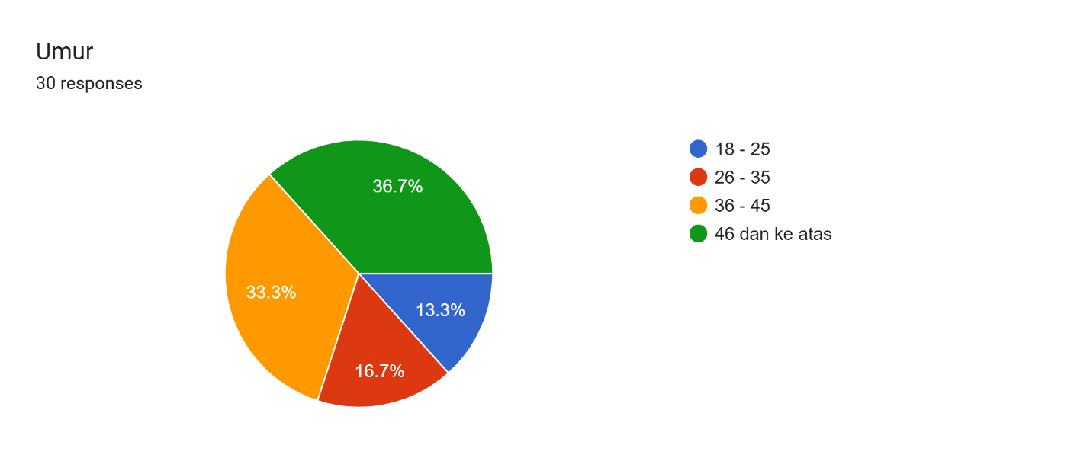
Figure 14: Pie Chart of Respondents’ Age Group
The gender distribution of the survey participants is depicted in the Figure 15. Among the 30 respondents:
- Female: Represent 60% of the respondents, indicating that a majority of the target users are women. This suggests that the app's design and content should consider female perspectives, particularly in addressing their specific literacy challenges and preferences.
- Male: Account for the remaining 40%, highlighting a smaller yet significant male user base.
The higher proportion of female respondents reflects their potential interest or need for the application, likely driven by their role in family education or community settings. Gender considerations in content presentation and cultural relevance could enhance the app's appeal and usability.
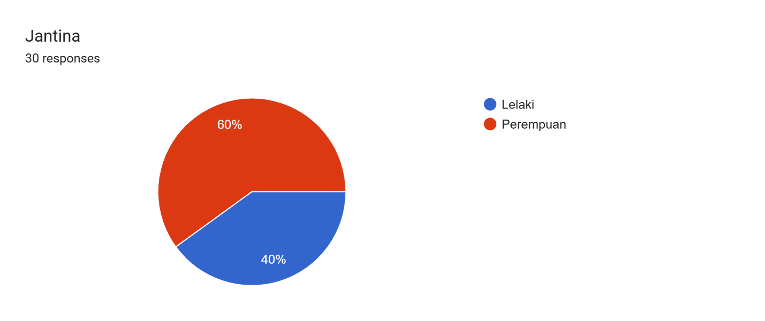
Figure 15: Pie Chart of Respondents’ Gender
The occupation distribution of the survey participants is shown in Figure 16. Among the 30 respondents:
- Housewife 53.3% dominate the respondent group, suggesting that the app should cater to those who may have limited mobility and education time at home.
- Self-employed (23.3%) and Labourers (20%) imply users may have demanding schedules, necessitating quick, flexible literacy lessons.
- Not working (3.3%) indicates potential opportunities for more engagement with users who have more available time.
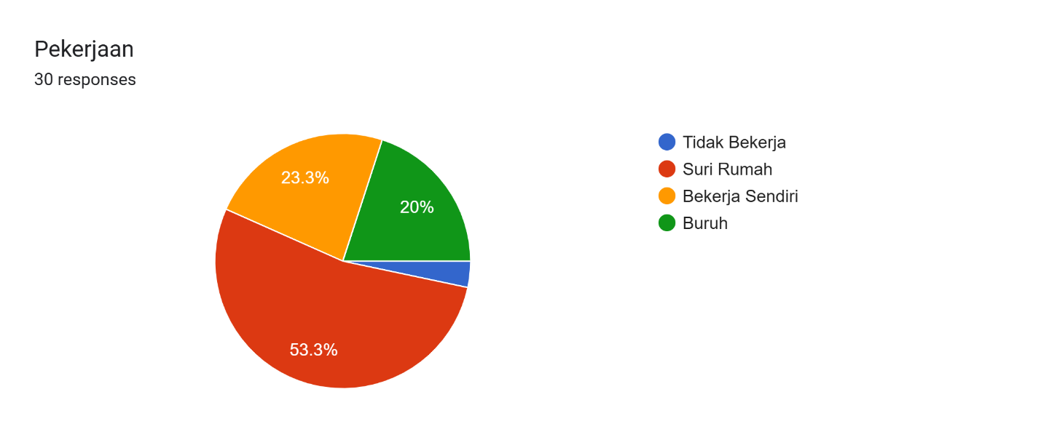
Figure 16: Pie Chart of Respondents’ Occupation
Figure 17 displays the survey respondents' location. Since all responders (100%) are from the Subis district, it is imperative that the app be customized to fit the unique linguistic and cultural context of this region.
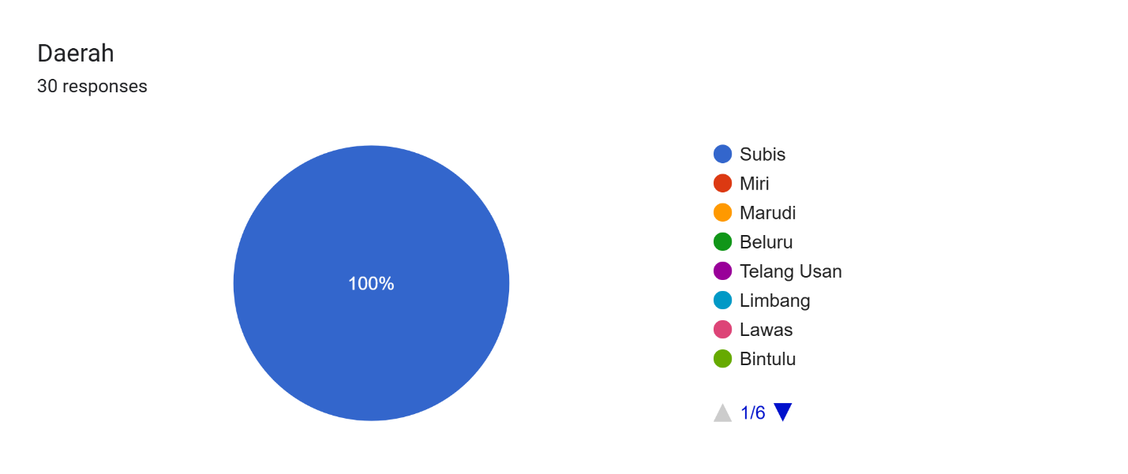
Figure 17: Pie Chart of Respondents’ Location

The primary language spoken by the survey participants is shown in Figure 18. All respondents primarily speak the Iban language, highlighting the importance of incorporating Iban language support and culturally relevant content in the app to enhance user engagement and effectiveness.
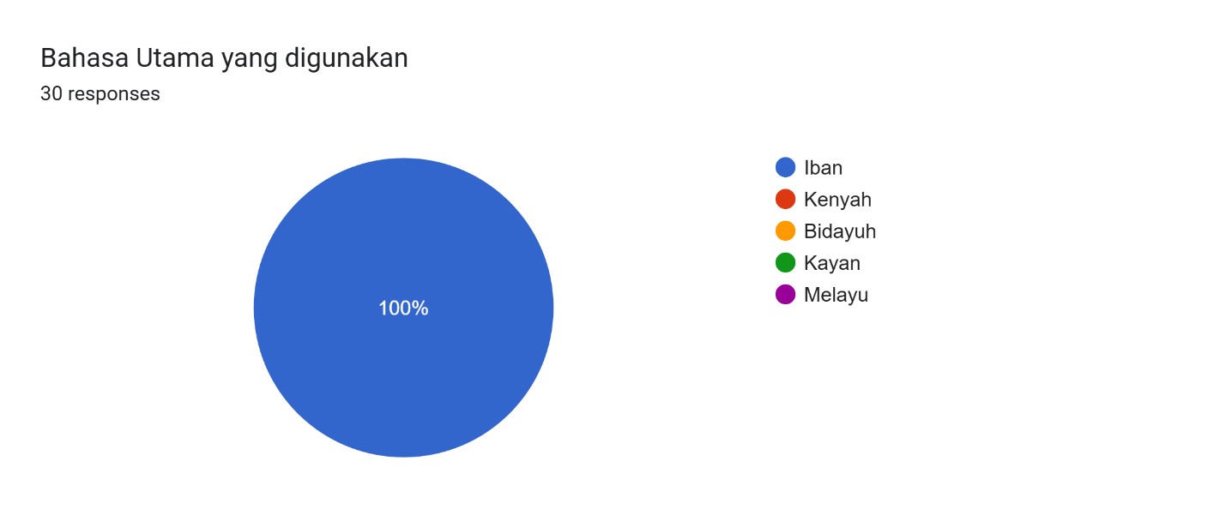
Figure 18: Pie Chart of Respondents’ Primary Language Spoken
The highest education of the survey participants is shown in Figure 19. The education levels of respondents show that 43.3% have no formal education, 46.7% have completed UPSR, 3.3% have PMR/PT3, and 6.7% have SPM. This indicates a need for the app to provide basic literacy support and cater to users with varying educational backgrounds.
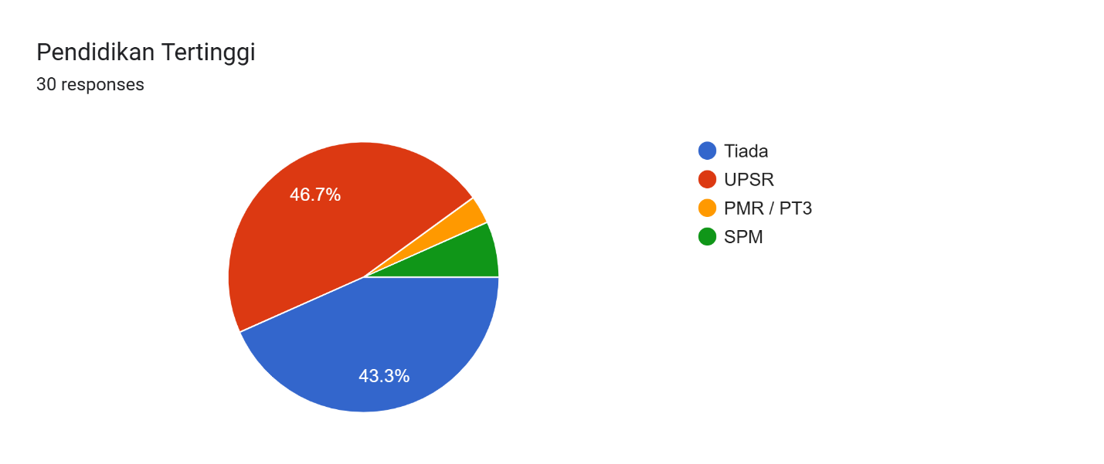
Figure 19: Pie Chart of Respondents’ Highest Education

Figure 20 below displays the survey respondents' Malay literacy level. 56.7% of respondents are unable to read and write in Malay, 36.7% have limited skills, and only 6.7% can. This emphasizes how important it is that the app provide thorough Malay literacy instruction at all skill levels.
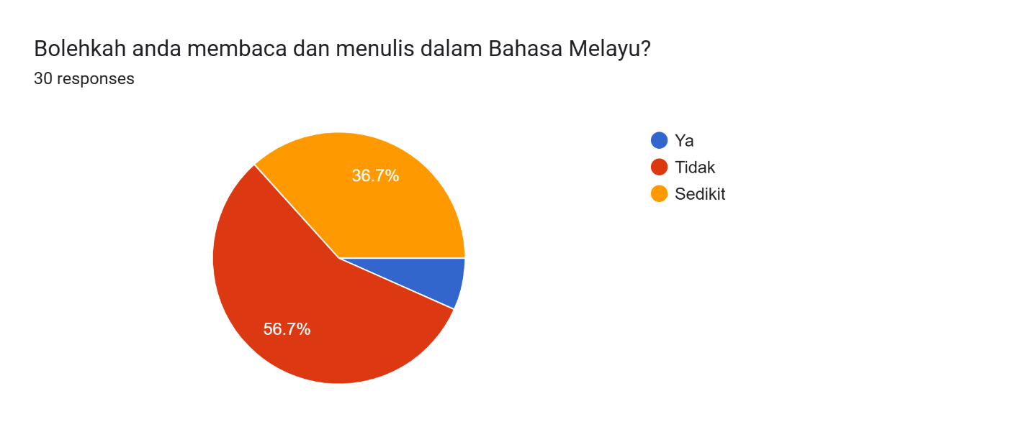
Figure 20: Pie Chart of Respondents’ Malay Literacy
Figure 21 illustrates the difficulties survey respondents had in enhancing their literacy. The main challenges faced by respondents include a lack of resources (75%), limited access to education (53.6%), lack of time (50%), and lack of motivation (32.1%). Addressing these challenges through the app's features, such as providing offline resources, flexible learning schedules, and motivational elements, will be crucial.
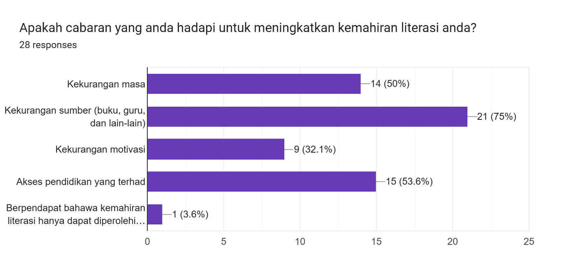
Figure 21: Bar Chart of Respondents’ Challenges in Improving Literacy
Figure 22 shows the respondents' involvement in educational programs. Among the 30 respondents: None of the respondents have participated in literacy programs before, indicating a significant gap that the app can fill by providing accessible and engaging literacy education.
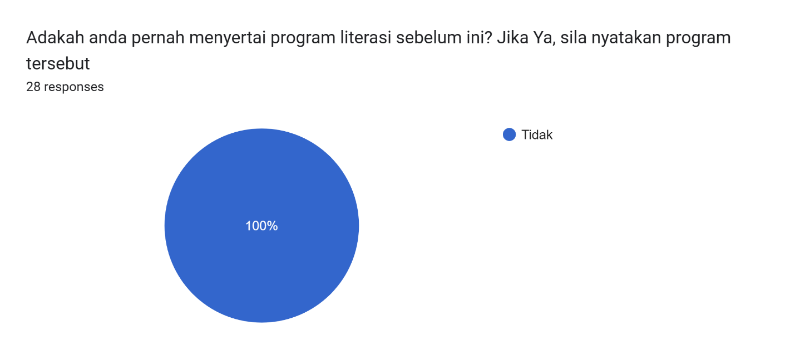
Figure 22: Pie Chart of Respondents’ Participation in Literacy Program
Figure 23 reveals the survey respondents' smartphone ownership. All respondents own a smartphone, which is a positive indicator for the app's potential reach and usability, as it can leverage the widespread availability of smartphones among the target users.
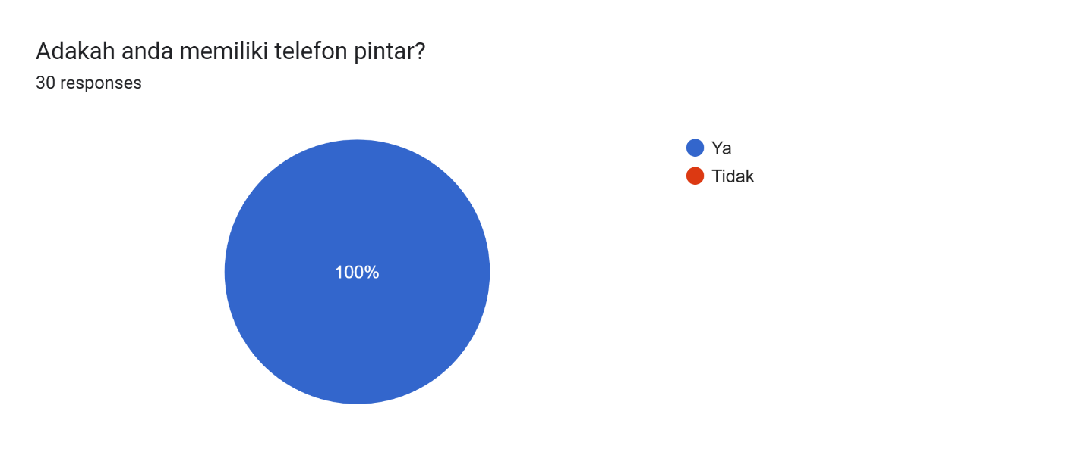
Figure 23: Pie Chart of Respondents’ Smartphone Ownership
Figure 24 highlights the survey respondents' smartphone usage frequency. Among the 30 respondents, 63.3% of respondents use their smartphones daily, 30% occasionally, and 6.7% rarely. This suggests that the app should be designed for frequent use, with features that encourage daily engagement.
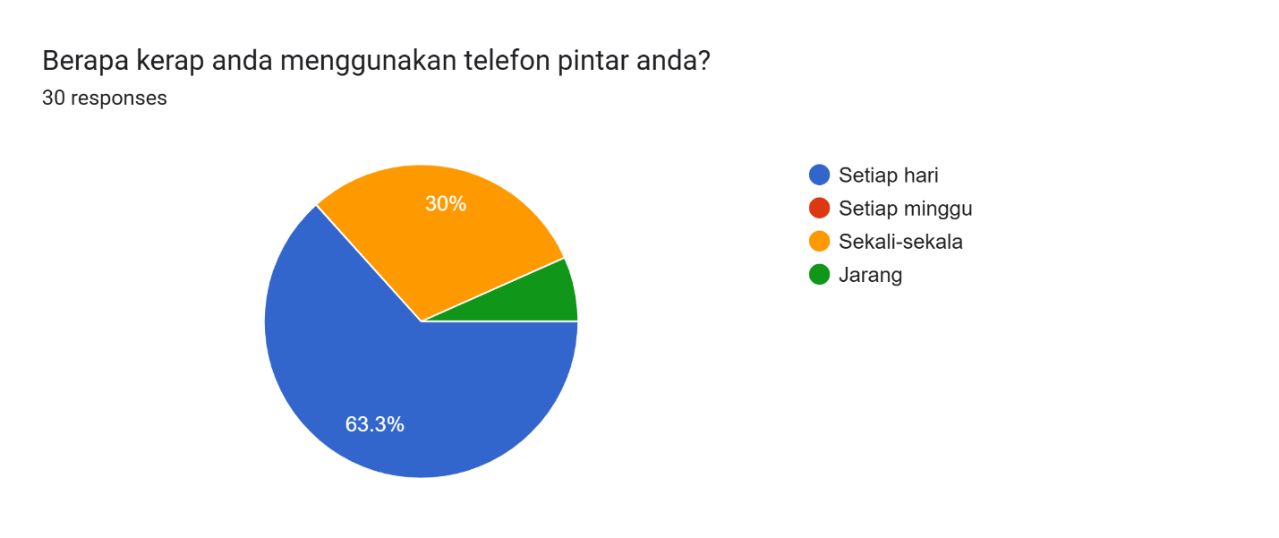
Figure 24: Pie Chart of Respondents’ Frequently of Smartphone Usage
Figure 25 displays the survey respondents' level of familiarity with mobile applications. The most used apps among respondents are WhatsApp (100%), YouTube (56.7%), Facebook (50%), and TikTok (46.7%). This indicates that the app should incorporate familiar elements and user interfaces from these popular apps to enhance user comfort and adoption.
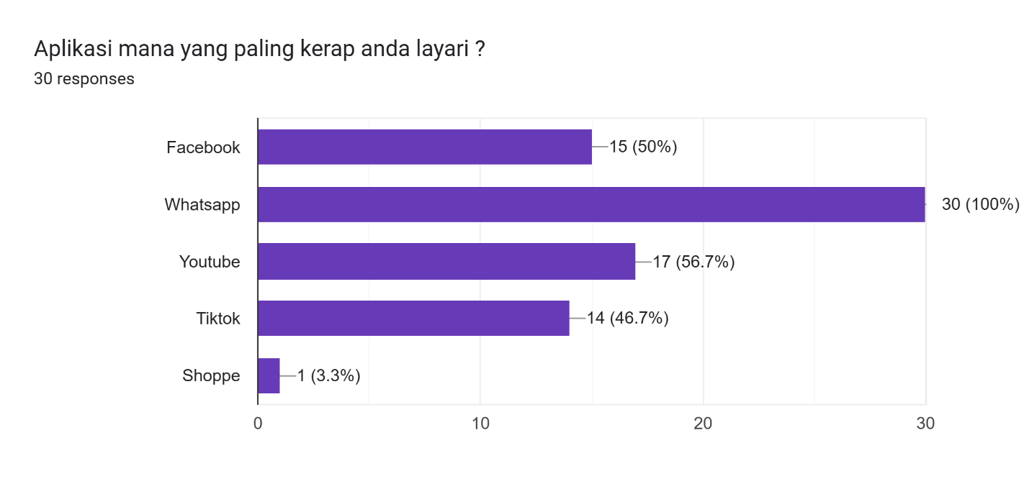
Figure 25: Bar Chart of Respondents’ Familiarity with Mobile Apps
The experience of the survey participants with educational applications is shown in Figure 26. None of the respondents have experience using educational apps or websites, highlighting the need for the app to provide an intuitive and user-friendly introduction to digital literacy tools.
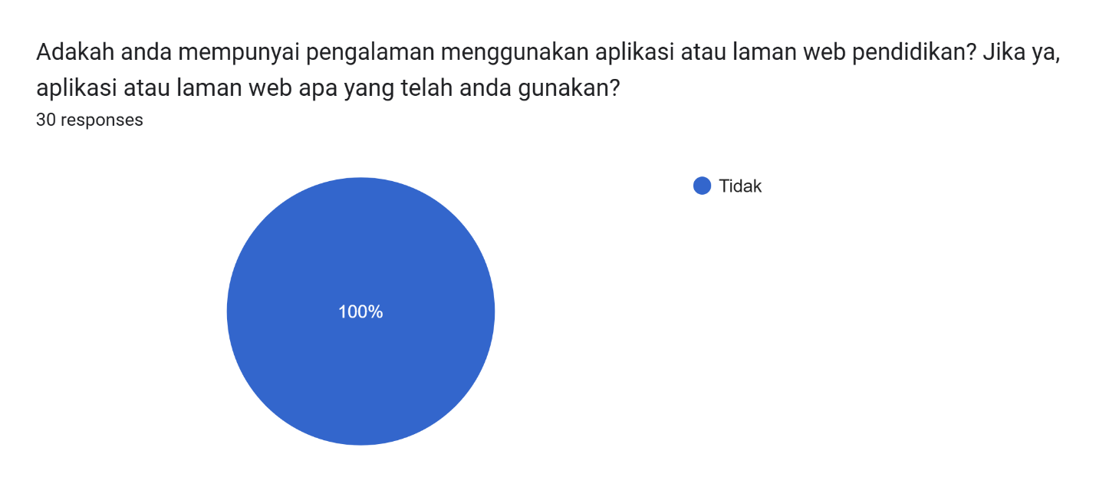
Figure 26: Pie Chart of Respondents’ Experience with Educational Apps

The preferred learning methods of the survey participants is shown in Figure 27. Respondents prefer watching videos (93.3%), interactive exercises (80%), reading and writing practice (80%), and listening to audio lessons (76.7%). The app should incorporate these preferred learning methods to maximize engagement and effectiveness.
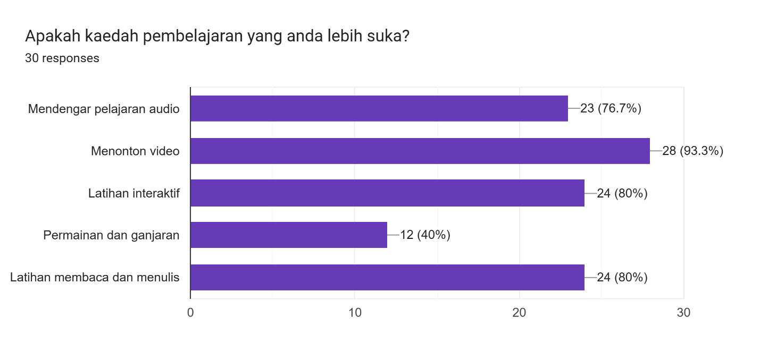
Figure 27: Bar Chart of Respondents’ Preferred Learning Methods

Most respondents are motivated by self-motivation (90%), family (70%), and community leaders (33.3%). The app should leverage these sources of encouragement by including features that support self-motivation, family involvement, and community engagement.
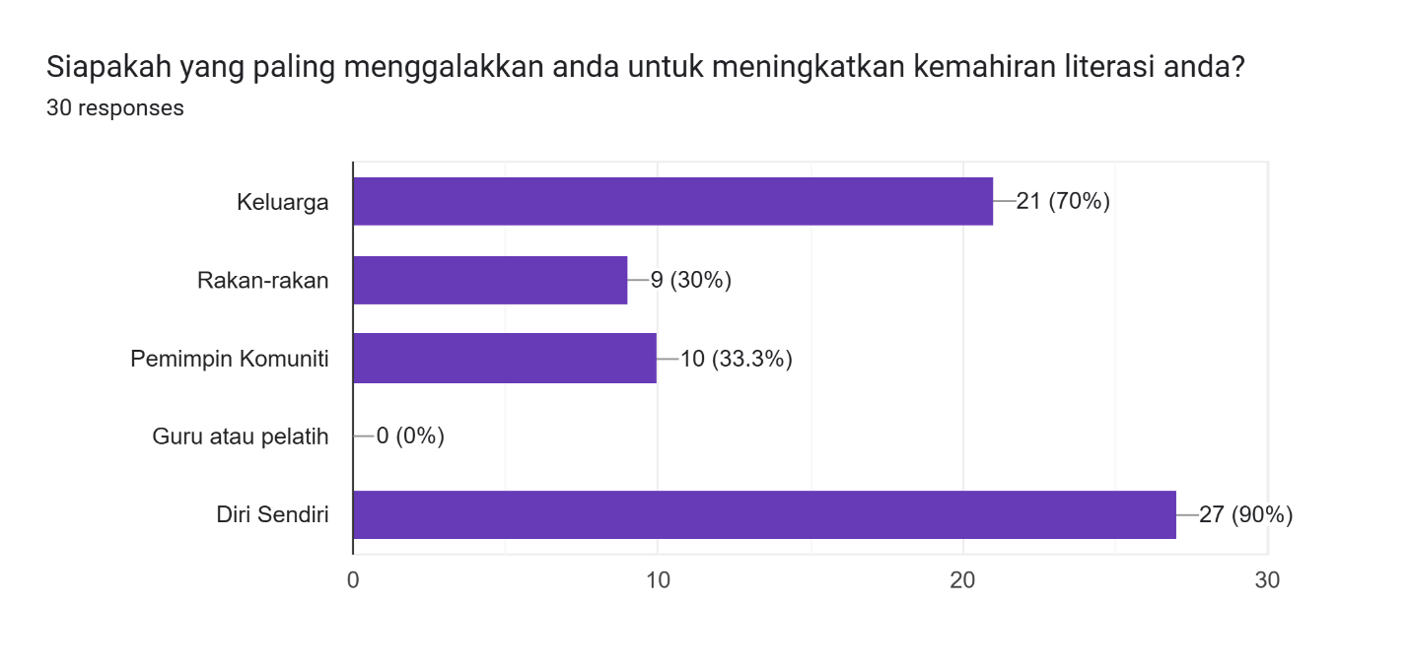
Figure 28: Bar Chart of Respondents’ Encouragement Sources
The motivational factors of the survey participants are shown in Figure 29. Respondents are motivated by clear results (83.3%), fun content (80%), rewards (50%), and family support (50%). Incorporating these motivational factors into the app's design, such as progress tracking, gamified content, rewards, and family support features, will enhance user motivation and retention.

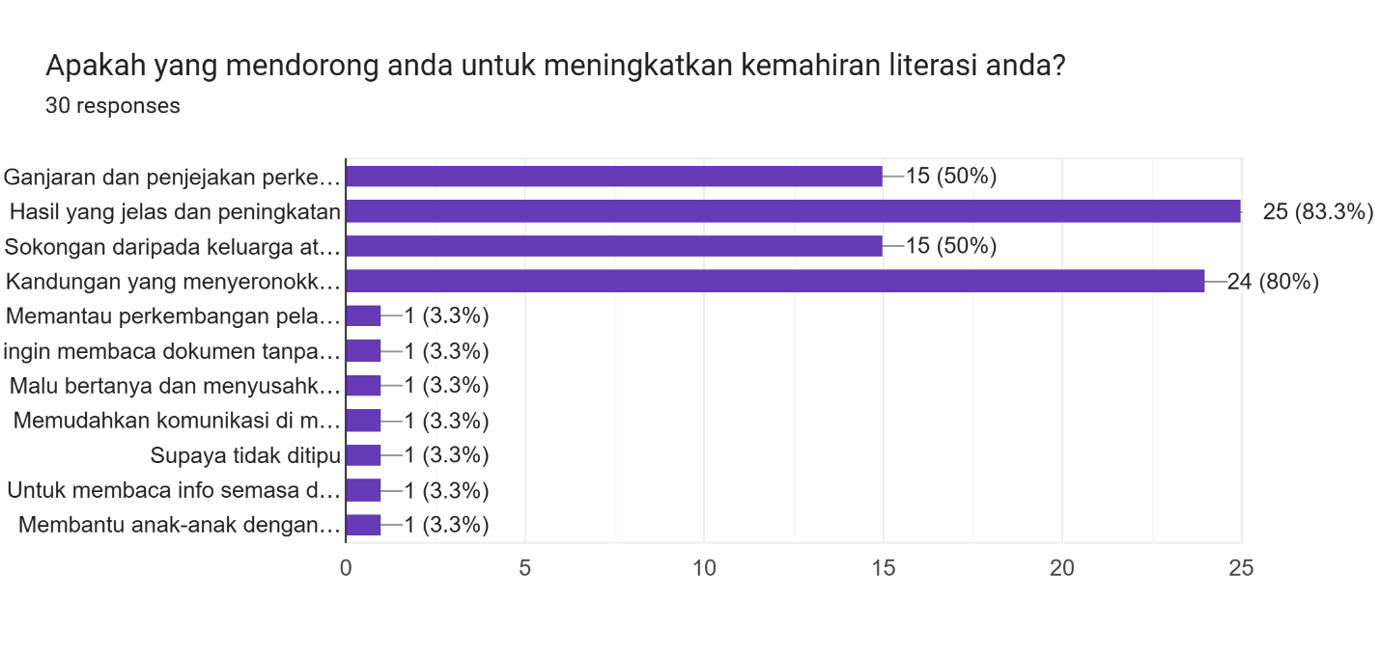
Figure 29: Bar Chart of Respondents’ Motivational Factors
The preferred application interface of the survey participants is shown in Figure 30. 70% of respondents prefer a combination of text and icons, while 30% prefer simple icon-based interfaces. The app should offer a balanced interface that combines text and icons to cater to user preferences.
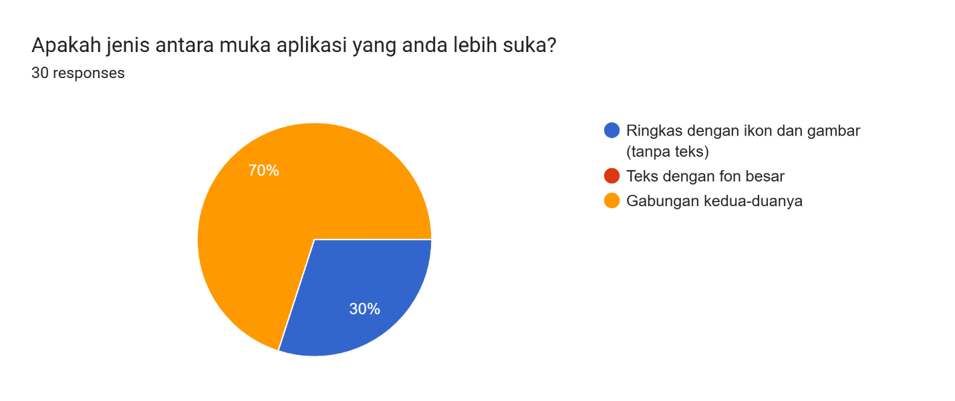
Figure 30: Pie Chart of Respondents’ Preferred App Interface
The navigation preference of the survey participants is shown in Figure 31. Most respondents (76.7%) prefer tapping on icons for navigation. The app should prioritize icon-based navigation to ensure ease of use and accessibility.
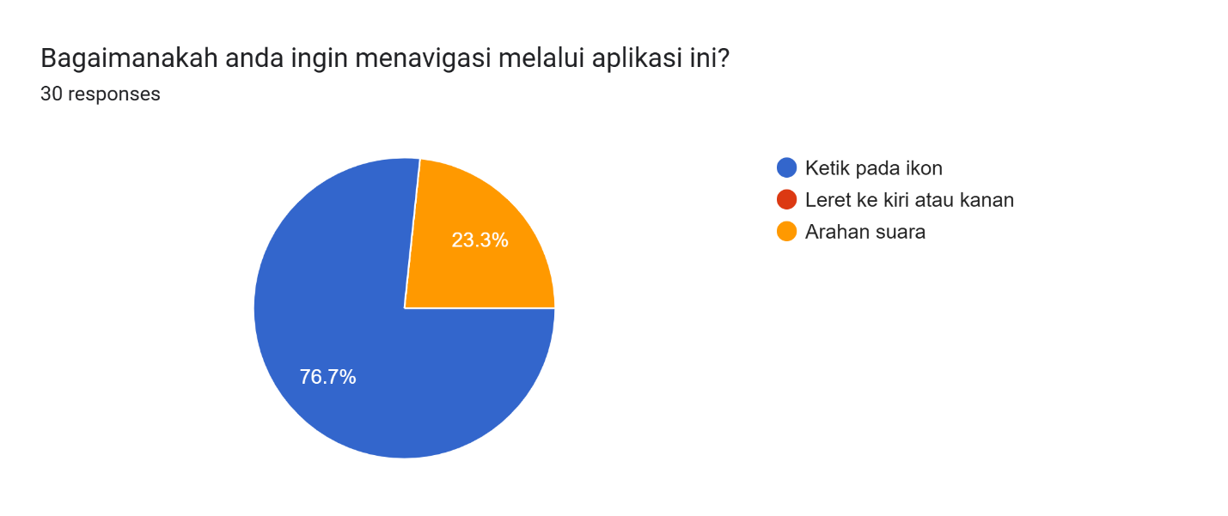
Figure 31: Pie Chart of Respondents’ Navigation Preference
The language preference of the survey participants is shown in Figure 32. 70% of respondents prefer audio instructions in Malay, while 23.3% prefer Malay text. The app should provide audio instructions in Malay to cater to the majority preference and support users with limited reading skills.
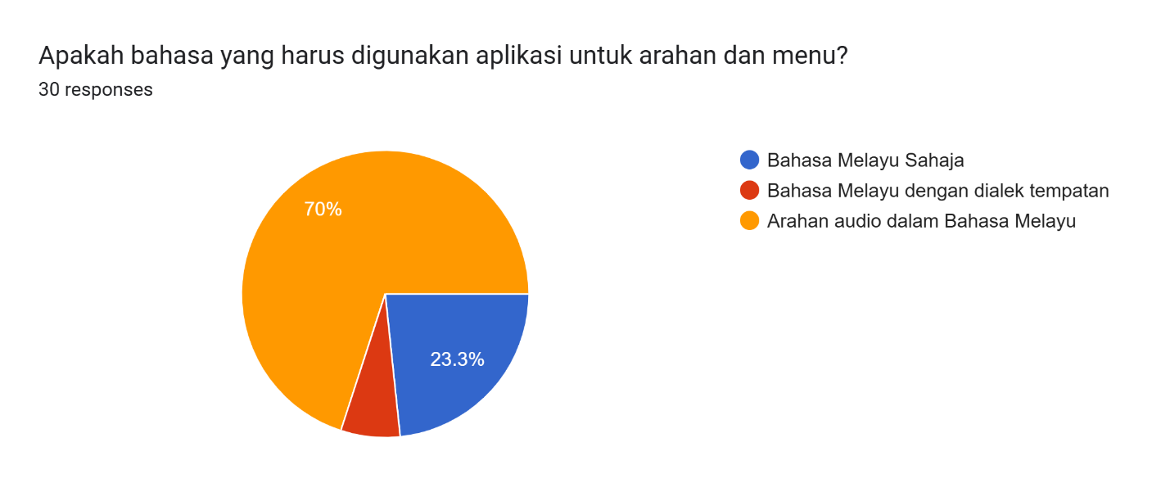
Figure 32: Pie Chart of Respondents’ Language Preference
The visual style preference of the survey participants is shown in Figure 33. 70% of respondents prefer a simple and clean visual design, 20% prefer bright and colorful styles, and 10% prefer traditional themes. The app should adopt a simple and clean visual design to appeal to the majority of users.

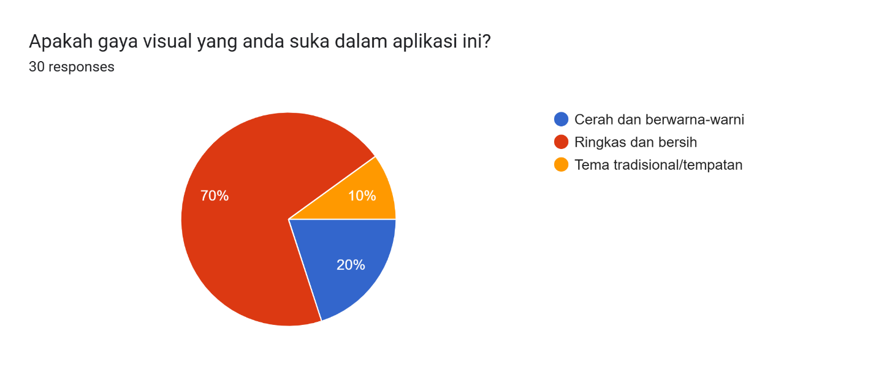
Figure 33: Pie Chart of Respondents’ Visual Style Preference
The importance of voice guidance for the survey participants is shown in Figure 34. 83.3% of respondents rate voice guidance as very important, with a score of 5 out of 5. The app should include comprehensive voice guidance to support users in navigating and using the app effectively.
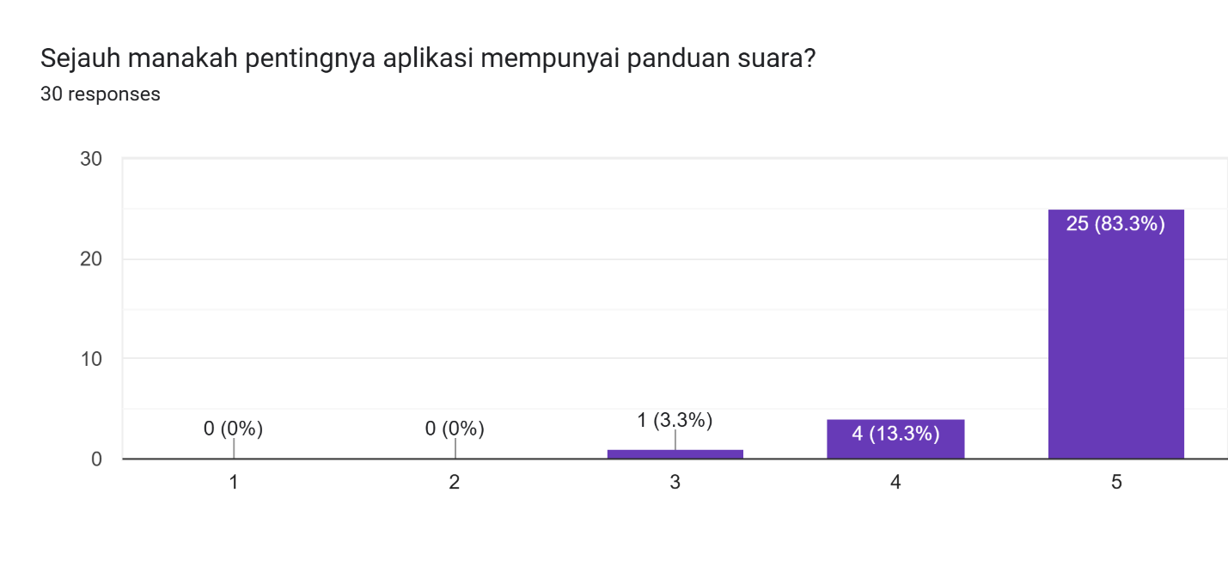
Figure 34: Bar Chart of Importance of Voice Guidance for Respondents

3.2.2 System Requirements
The project relies on several essential software tools to ensure efficient development and functionality.

3.2.2.1 Hardware Requirement
The hardware requirement that are suitable for this proposed platform and its development journey are as stated below in Table 8. The laptop is required to install and access all the required software to develop the project.
Table 8:Device Specification and Description
Device Specification | Description
Processor | 11th Gen Intel(R) Core (TM) i5-11400H @ 2.70GHz 2.69 GHz
Installed RAM | 8GB DDR4
Storage | 512 SSD
Operating System | 64-Bit operating system, x64-based processor
Windows Version | Windows 11 Home Single Language
Graphic Card | GeForce RTX 2050

3.2.2.2 Software Requirement
Software requirements are also important to ensure complete execution of the project. The
software requirements for the proposed online learning platform are stated below in Table 9.
Table 9: Software and Description
Software | Description
Figma | For prototyping and interface design.
Android Studio | The primary integrated development environment (IDE) for developing, testing, and debugging the app.
Flutter | Framework for app development.
Firebase | To store the data.

3.2.3 Functional Requirements
The proposed application must meet several functional requirements to ensure it effectively serves its intended purpose. Below is the list of functional requirements of this proposed application:
- Users must be able to access phonics-based lessons in Malay.
- The app should provide speech recognition feedback for pronunciation practice.
- Gamified features, such as quizzes, progress tracking, and rewards, must be integrated.
- Offline access must allow users to download lessons and use them without internet connectivity.
- The app should support user registration and login for personalized progress tracking.

3.2.4 Non- Functional Requirements
The application must also adhere to several non-functional requirements to ensure a positive user experience and reliable performance. Below is the list of non-functional requirements of this proposed application:
- The app must have a user-friendly interface with clear icons and local imagery.
- It should function on low-end Android devices to ensure accessibility.
- The system must maintain data privacy and security for user information.
- The app should support offline functionality with minimal storage requirements.

3.2.5 Accessibility Features
To address the diverse needs of users, the following accessibility features are included:
- Font Size and Readability: Adjustable font sizes and high-contrast themes for users with vision impairments.
- Voice Guidance: Audio navigation to assist users with low digital literacy.
- Simplified Navigation: Minimalistic interface to reduce cognitive load.

3.2.6 Culture Considerations
Cultural considerations are integral to the app's design and functionality.
- Supporting local languages and dialects.
- Including culturally relevant imagery and examples.
- Ensuring feedback from the community leaders to enhance culture appropriateness.

3.3 System Design
This section provides a detailed explanation of the BacaSama system’s design, including its architectural components and various UML diagrams that represent system behaviour and interactions.

3.3.1 Overview
The BacaSama system design incorporates modular architecture, ensuring scalability and maintainability. The primary components include:
- Frontend Module: Developed using Flutter for dynamic, interactive user interfaces.
- Backend Module: Powered by Firebase, managing authentication, user data, and lesson content.
- Speech Recognition API: Integrated for phonics feedback and pronunciation assessment.
- Gamification Engine: Tracks progress, generates rewards, and enhances user engagement.

3.3.2 Use Case Diagram
The Use Case Diagram visually represents the interactions between the user and various system functionalities. It includes the primary user actions and their dependencies.
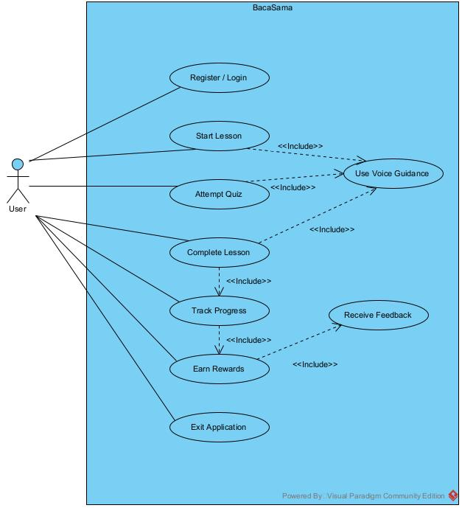
Figure 35: Use Case Diagram for BacaSama
Figure 35 above shows the Use Case Diagram for BacaSama illustrates how a User interacts with the system's various functionalities. The user can perform actions such as Register/Login, Start Lesson, Attempt Quiz, Complete Lesson, Track Progress, Earn Rewards, and Exit Application. Some of these actions include additional functionalities through the "<<include>>" relationships. For instance, both "Start Lesson" and "Attempt Quiz" include "Use Voice Guidance", which suggests that voice assistance is available during these activities. Similarly, "Complete Lesson" leads to "Track Progress", which then connects to "Earn Rewards" if progress milestones are achieved. Additionally, "Track Progress" includes "Receive Feedback", ensuring users receive necessary learning insights. The diagram effectively showcases the structured interaction between the user and the system, emphasizing voice support, feedback, and gamification elements.

3.3.3 Use Case Description
Below are the detailed use case specifications for the BacaSama application. Each table provides a breakdown of the use case ID, description, actor, preconditions, postconditions, main flow, alternative flows, and any relationships such as Include or Extend.
Table 10: Use Case Description for Register/Login
Use Case ID | 1
Use Case | Register/Login
Description | User registers a new account or logs into an existing one.
Actor | User
Precondition | User has the app installed.
Postcondition | User is authenticated and directed to the dashboard.
Main Flow | 1. User opens the app.  2. User selects “Register” or “Login.”  3. If registering, enters details (name, email, password).  4. If logging in, enters existing credentials.  5. System authenticates and redirects to Dashboard.
Alternative Flow | If authentication fails, the system prompts user to re-enter credentials or reset password.

Table 11: Use Case Description for Starting a Lesson
Use Case ID | 2
Use Case | Start Lesson
Description | The user selects and begins a lesson, and the system automatically stores it for offline access.
Actor | User
Precondition | User is logged in.
Postcondition | Lesson content is displayed.
Main Flow | 1. User selects a lesson.  2. System loads lesson content.  3. System automatically saves the lesson for offline use.
Include | Use Voice Guidance – System reads instructions aloud for users.
Alternative Flow | If the lesson was previously cached, it loads from offline storage instead of the internet.

Table 12: Use Case Description for Completing a Lesson
Use Case ID | 3
Use Case | Complete Lesson
Description | Users progress through lesson content.
Actor | User
Precondition | User has selected a lesson.
Postcondition | Lesson completion is recorded in progress tracking.
Main Flow | 1. User reads/listens to lesson materials.  2. Completes interactive exercises.  3. System marks lesson as completed.
Include | Use Voice Guidance – Assists user in navigating lesson content.  Track Progress – Updates user's learning record.

Table 13: Use Case Description for Attempting Quiz
Use Case ID | 4
Use Case | Attempt Quiz
Description | User answers quiz questions at the end of each lesson.
Actor | User
Precondition | User has completed a lesson.
Postcondition | Quiz results are recorded, and feedback is given.
Main Flow | 1. User selects "Take Quiz" after lesson.  2. Answers multiple-choice or interactive questions.  3. System records responses and evaluates performance.
Extend | Receive Feedback – Provides corrections if wrong answers are given.
Alternative Flow | If the quiz fails, the system suggests retrying the lesson.

Table 14: Use Case Description for Receiving Feedback
Use Case ID | 5
Use Case | Receive Feedback
Description | The system provides feedback on quiz performance.
Actor | System
Precondition | User has attempted a quiz.
Postcondition | User understands their mistakes and can improve.
Main Flow | 1. System evaluates quiz answers.  2. Provides explanations for incorrect answers.  3. Displays the final score.
Include | Use Voice Guidance – Reads out the correct answers and explanations.

Table 15: Use Case Description for Tracking Progress
Use Case ID | 6
Use Case | Track Progress
Description | User can view completed lessons and scores.
Actor | User
Precondition | User has completed at least one lesson or quiz.
Postcondition | Progress is saved for future reference.
Main Flow | 1. User navigates to "Progress" section.  2. System displays completed lessons and quiz scores.  3. User can see achievements and next steps.
Include | Earn Rewards – If milestones are reached.

Table 16: Use Case Description for Earning Rewards
Use Case ID | 7
Use Case | Earn Rewards
Description | User unlocks badges or points as they progress.
Actor | System
Precondition | User has completed specific milestones.
Postcondition | Motivation is increased through gamification.
Main Flow | 1. System tracks milestones (e.g., completing 5 lessons).  2. User unlocks achievements (badges, stars, certificates).  3. Rewards are displayed in the Progress section.
Extend | Track Progress – Links to user's learning record.

Table 17: Use Case Description for Using Voice Guidance
Use Case ID | 8
Use Case | Use Voice Guidance
Description | Provides spoken instructions for illiterate users.
Actor | System
Precondition | User is navigating the app.
Postcondition | User can interact with the app without reading text.
Main Flow | 1. System detects user actions (e.g., selecting a button).  2. Reads out instructions or lesson content.  3. Assists user in completing tasks.
Include | Start Lesson, Complete Lesson, Receive Feedback – Voice guidance is available in all learning stages.

Table 18: Use Case Description for Exiting Application
Use Case ID | 9
Use Case | Exit Application
Description | User logs out or closes the app.
Actor | User
Precondition | User is logged in.
Postcondition | Session ends.
Main Flow | 1. User selects "Log Out" or closes the app.  2. System saves progress.  3. User exits safely.
Alternative Flow | If progress is unsaved, system prompts user to sync data.

3.3.3 Sequence Diagram
The Sequence Diagram illustrates the step-by-step interactions between system components for various user actions.

3.3.3.1 User Registration / Login
Figure 36 depicts the authentication activity for the users.
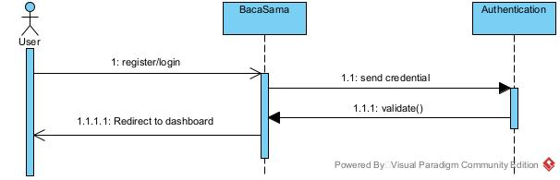
Figure 36: Sequence Diagram for User Registration/ Login

3.3.3.2 Start Lesson & Complete Lesson
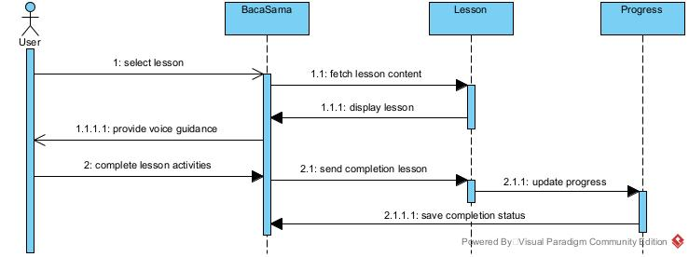
Figure 37: Sequence Diagram for Starting and Completing Lesson

3.3.3.3 Attempt Quiz & Receive Feedback
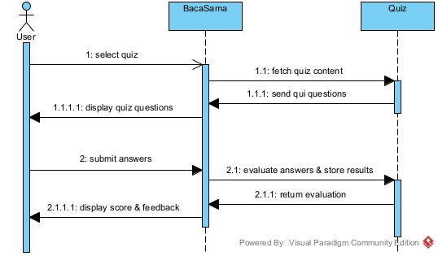
Figure 38: Sequence Diagram for Attempting Quiz and Receiving Feedback

3.3.3.1 View Progress and Earn Reward
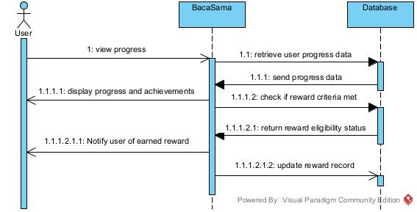
Figure 39: Sequence Diagram for Viewing Progress and Earning Reward

3.3.4 Class Diagram
The Class Diagram in Figure 40 represents a learning system where users can access lessons, attempt quizzes, track their progress, and earn rewards. Each User has a unique profile with details like name, email, and literacy level. They can start lessons, which contain educational content and quizzes to test their knowledge. After attempting a Quiz, users receive scores and feedback. Their learning journey is tracked through the Progress class, which records completed lessons, quiz scores, and achievements. To keep users motivated, the system grants Rewards based on their progress. This structured approach helps users improve their literacy skills while keeping them engaged with interactive learning experiences.
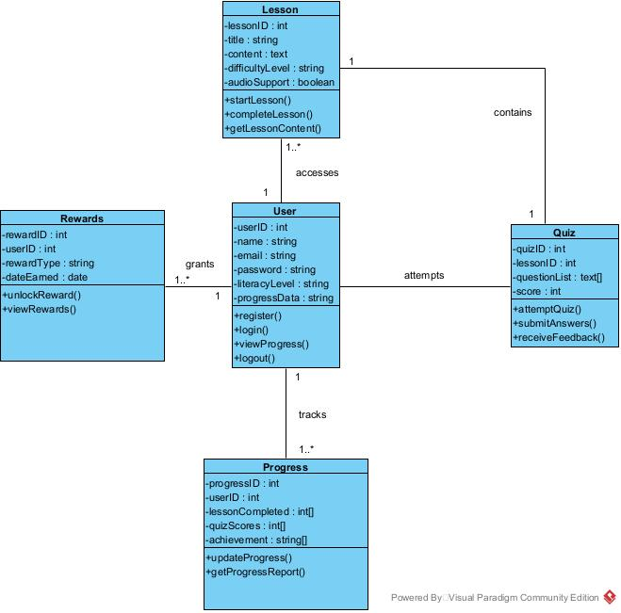
Figure 40: Class Diagram for BacaSama

3.3.5 State Diagram
The state diagram in Figure 41 illustrates the various states a user can experience while interacting with BacaSama, an educational application designed to facilitate learning through structured lessons. The process begins with the user registering or logging in. Upon a successful login, the user is directed to the Dashboard, where they can choose a lesson. Once a lesson is selected, the user enters the Lesson-In state, where they can navigate through the content, track their progress, and submit answers to quizzes. After completing a lesson, the user can continue learning or finish the lesson, which may lead to earning rewards or unlocking achievements. The user can also view their scores and receive feedback. The interaction concludes when the user logs out or exits the application.
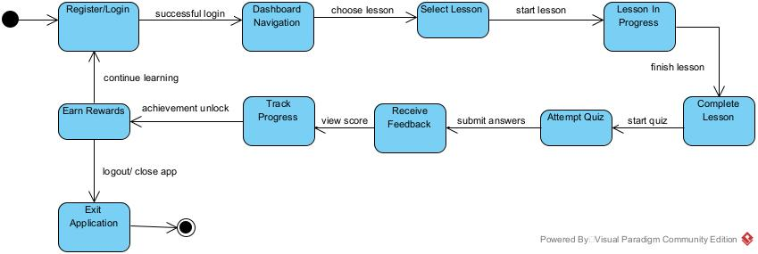
Figure 41: State Diagram for BacaSama

3.3.6 Component Diagram
The Component Diagram depicts the high-level system architecture and how different modules interact which can be refer in Appendix D.

3.3.7 Interface Design
This section provides mockups and descriptions of key app screens, including:
- Login/Registration Screen:
Figure 38 below shows the Login/Registration Screen offers users three options to sign in: Facebook, Google, or email. The interface is simple and user-friendly, with clear instructions to guide users through the process. This screen ensures a smooth and quick login experience, allowing users to access the app effortlessly.

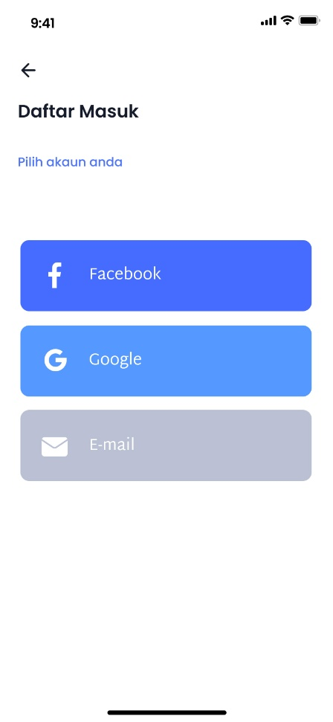
Figure 42: Login Screen for BacaSama
- Dashboard:
The Dashboard as shown in Figure 39 displays the user's lessons, progress, and achievements. It provides an overview of the user's learning journey, highlighting completed lessons, ongoing activities, and achievements. This screen helps users stay motivated and track their progress effectively.
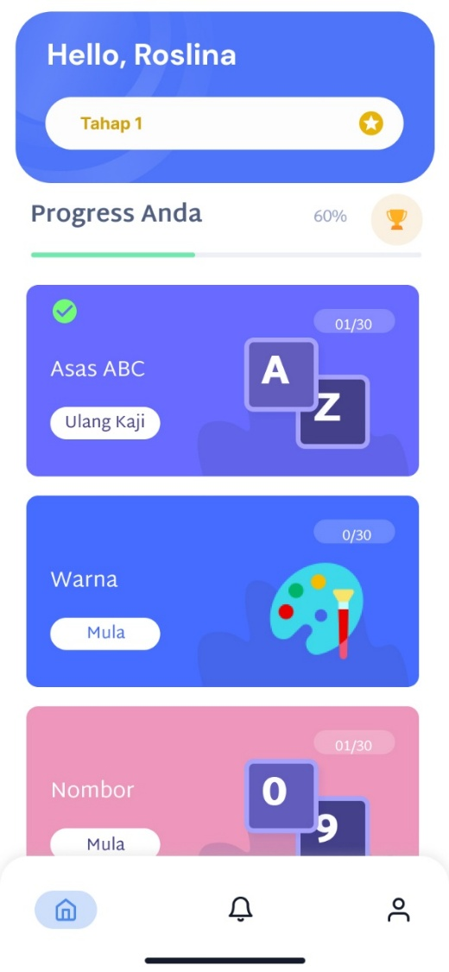
Figure 43: Dashboard Screen for BacaSama
- Lesson Preview Screen:
The Lesson’s Preview Screen in Figure 40 below provides a sneak peek into the upcoming lessons. It gives users an overview of the content they will be learning, helping them prepare for the lessons ahead. This screen is designed to build anticipation and keep users engaged with the learning material.
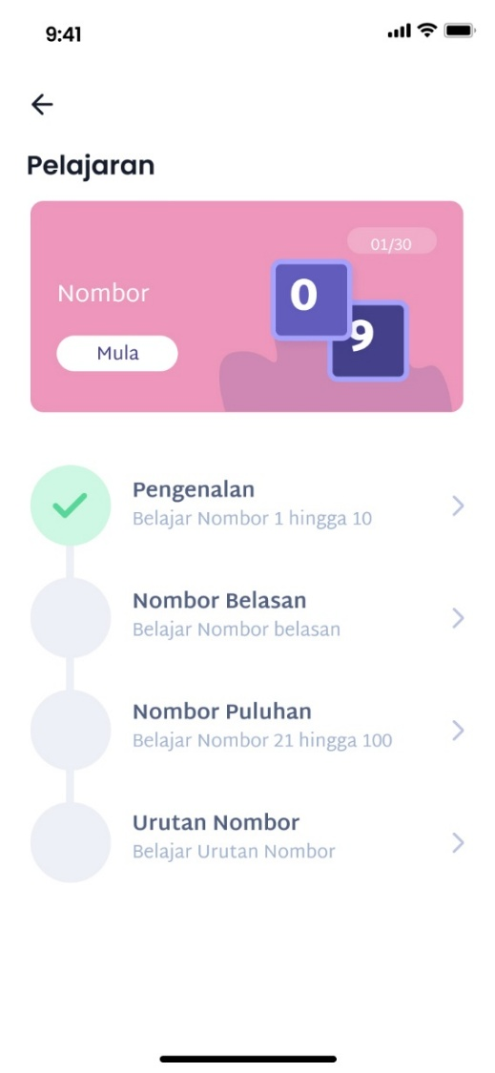
Figure 44: Lesson’s Preview Screen for BacaSama
- Lesson Screen:
Figure 41 shows the Lesson Screen features, an interactive design with phonics exercises and speech recognition. It engages users with interactive activities that enhance their learning experience. The screen is designed to be intuitive and user-friendly, making it easy for users to navigate through the exercises and practice their phonics skills.
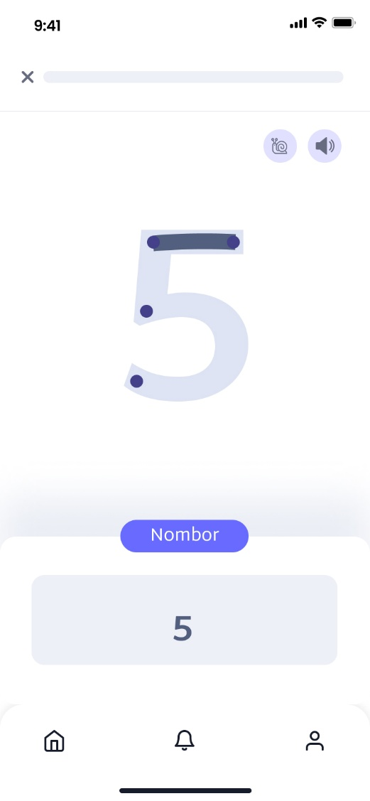
Figure 45: Lesson with Exercise for BacaSama

3.3.8 Technical Architecture
The application architecture includes:
- Cloud Infrastructure: Firebase for hosting user data and real-time updates.
- APIs: Integration of third-party APIs for speech recognition and gamification
- Scalability Considerations: Ensuring the app handles increased user load efficiently.

3.3.9 Security Features
To protect user data:
- Authentication Mechanisms: Firebase ensures secure login and data access.
- Data Encryption: User data is encrypted during transmission and storage.
- Privacy Compliance: The app complies with data protection laws

3.4 Summary
This chapter detailed the requirements analysis and design for the BacaSama literacy application. Through a systematic approach to gathering requirements and a detailed system design, the proposed application is expected to address literacy challenges among adults in rural Sarawak. By integrating phonics-based lessons, speech recognition, and gamification, the app not only aims to improve literacy but also ensures an engaging and accessible user experience.

CHAPTER 4: DEVELOPMENT AND IMPLEMENTATION

4.1 Introduction
This chapter discusses the implementation phase of the BacaSama mobile application, highlighting the overall development environment, tools and frameworks used, installation procedures, and development progress. It presents the step-by-step execution of features aligned with the system design and user requirements gathered earlier. The goal is to demonstrate how the application was built to support literacy learning for illiterate adults in rural Malaysia.

4.2 Implementation Overview
BacaSama was developed using Flutter as the frontend framework and Firebase as the backend solution, integrating speech recognition and gamification elements. The project followed an iterative development cycle under the Rapid Application Development (RAD) model, which emphasizes rapid prototyping, user feedback, and progressive refinement of the app's core features.
The main modules implemented during development include:
- User Registration/ Login
- Lesson Module (Alphabet, Syllables, Words, Sentences)
- Quiz and Reward System
- Progress Tracking
- Offline Support and Voice Guidance
Each module was developed and tested in cycles, starting with wireframe prototyping in Figma and ending with full feature testing in the emulator and real devices.

4.3 Implementations and Development Logs

4.3.1 Requirement Planning Phase
Surveys were conducted among 30 adults from rural Sarawak (Niah, Subis) to gather data on literacy levels, challenges, and user preferences. The findings were used to define functional and non-functional requirements.

4.3.2 User Design Phase
Wireframes and low-fidelity prototypes were created using Figma. Feedback from target users and supervisors was incorporated to refine the user interface, ensuring it remains intuitive and friendly for illiterate users. Icon-based navigation, voice guidance, and minimal text were emphasized.

4.3.3 Construction Phase
The app modules were developed incrementally:
- Login & Registration Module: Integrated Firebase Authentication.
- Lesson Module: Displays phonics, suku kata, words, and sentences with audio.
- Quiz Module: Provides multiple-choice and interactive tasks with gamified rewards.
- Progress Tracking Module: Allows users to view completed tasks and achievements.
- Offline Support: Lessons are automatically cached upon first load for offline use.

4.3.4 Cutover Phase
The system was tested using real devices. Functional testing, component testing, and integration testing were carried out. Feedback from test users helped refine certain functions, particularly voice playback speed and icon clarity.

4.4 Key Implementation Features

4.4.1 Voice Guidance
Voice output was implemented using Google TTS API. Every action or screen displays spoken instructions in Bahasa Melayu to support illiterate users.

4.4.2 Gamification
The reward system motivates users to complete lessons. Badges are awarded upon completion of tasks. User progress is visualized with a growth tree or progress bar.

4.4.3 Offline Accessibility
Offline features were implemented using Firebase local persistence. Lesson modules are cached on first access and stored in the device for later usage without the internet.

4.4.4 Progress Tracking
A Firebase real-time database tracks which lessons and quizzes are completed. The system also displays badges or rewards in the dashboard module.

4.5 Interface Implementation
- Login/Register: Displays two main buttons, icons with audio labels.
- Dashboard: Colorful layout with lesson modules (Huruf, Suku Kata, Perkataan, Ayat).
- Lesson Interface: Shows images, letter animations, and play button for pronunciation.
- Quiz Interface: Question with 3 picture choices, feedback after each question.
- Settings: Language toggle, voice speed, logout option.

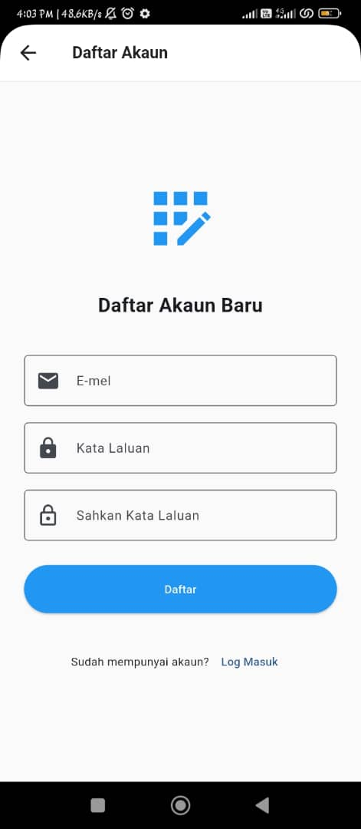
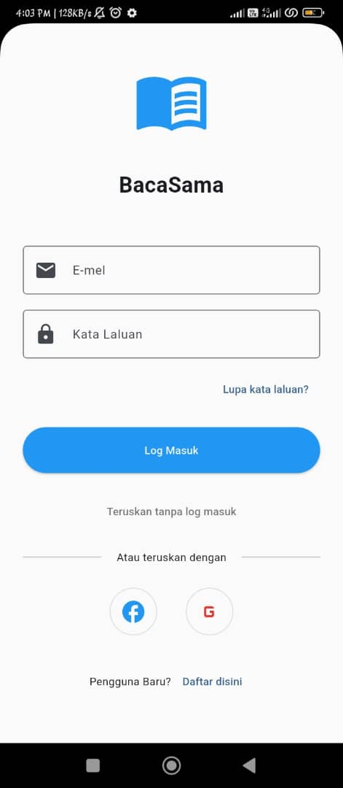
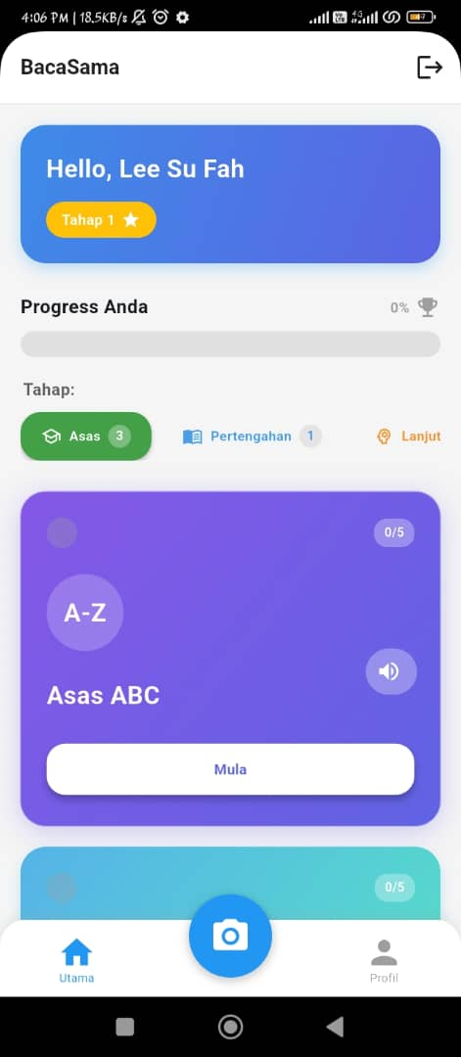
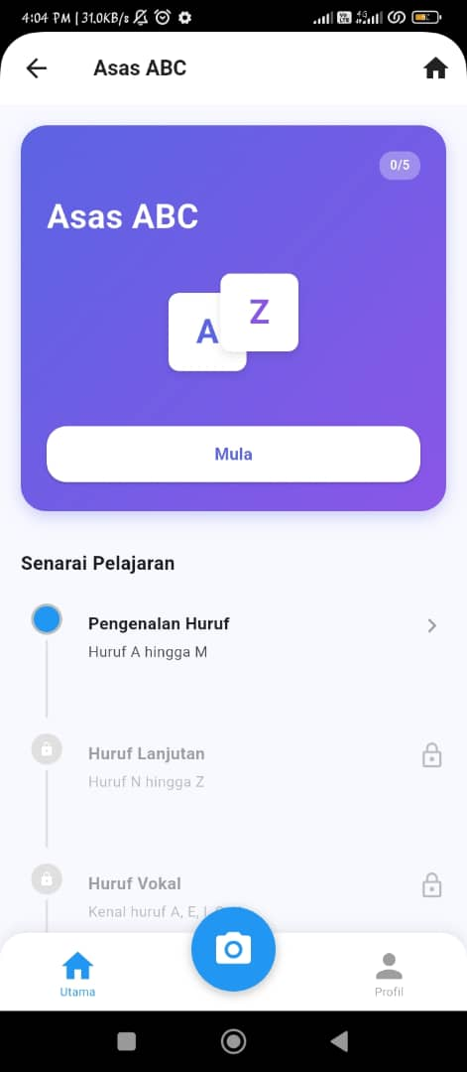
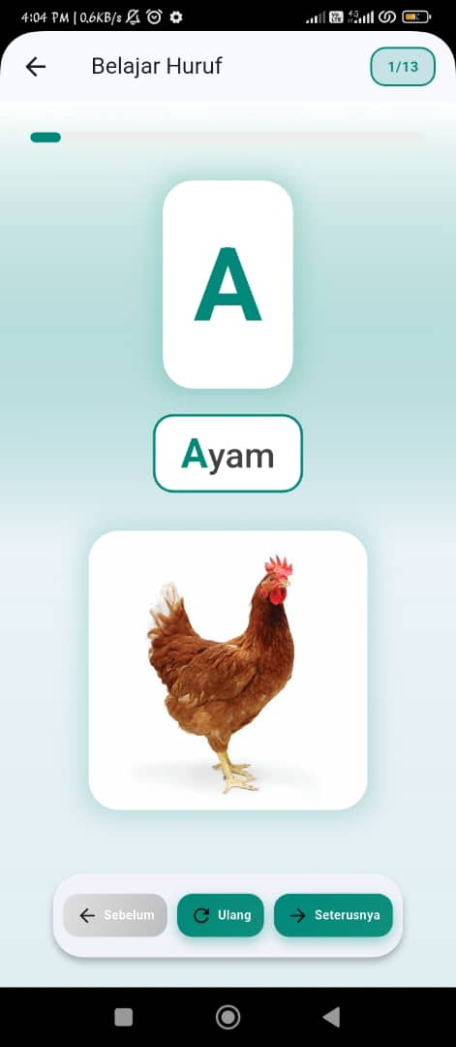
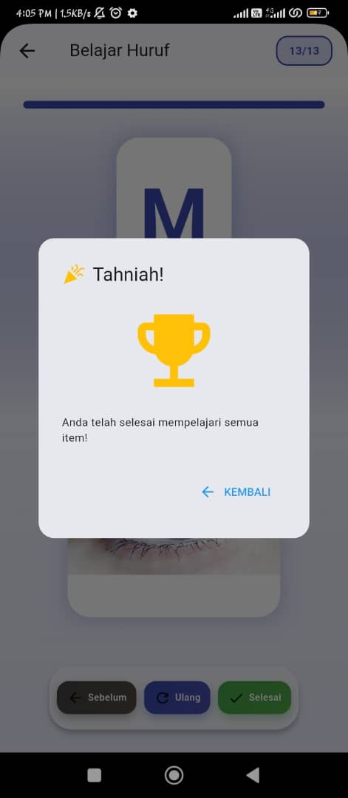
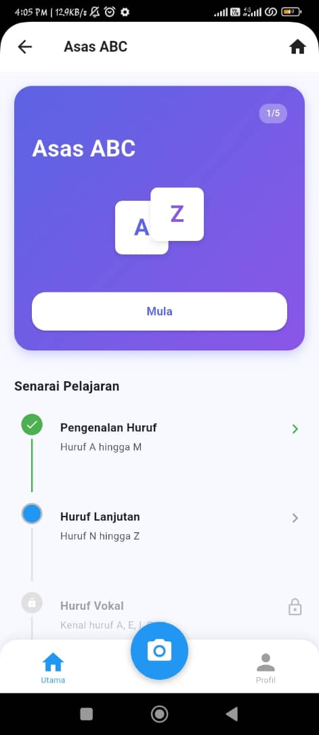

4.6 Summary
This chapter highlighted the tools, RAD methodology, and implementation of core features in the BacaSama application. The integration of voice guidance, offline learning, gamification, and user-friendly interface ensures that the app meets the specific needs of adult illiterate learners in rural areas. The successful implementation phase lays the foundation for comprehensive testing and evaluation in the next chapter.

REFERENCES
Adminit. (2022, August 25). Indigenous Functional Literacy Program (PLFOA). Laman Web Rasmi Jabatan Kemajuan Orang Asli. https://www.jakoa.gov.my/indigenous-functional-literacy-program-plfoa/?lang=en
Bernama. (2023, Nov 20). Kolaborasi Jakoa-kemas Bantu Literasi Orang Asli. https://www.bernama.com/bm/news.php?id=2245990
Casey, J. (2023, Jan). Citizen Literacy: A White Paper. Citizen Literacy Community Interest Company. https://citizenliteracy.com/wp-content/uploads/2023/01/Citizen_Literacy_White-Paper_06_Jan_2023.pdf
Government of Malaysia. (1971). Age of Majority Act 1971.
Harian Sarawak. (2024). Basmi buta huruf di kawasan pedalaman negeri ini – Harden. https://www.hariansarawak.com/2024/07/22/basmi-buta-huruf-di-kawasan-pedalaman-negeri-ini-harden/
Ibrahim, R. (2020, Dec 29). 25 ibu bapa Orang Asli tamat kelas dewasa. Harian Metro. https://www.hmetro.com.my/mutakhir/2020/12/658147/25-ibu-bapa-orang-asli-tamat-kelas-dewasa-metrotv#google_vignette
Lambai, K. (2023, June 25). Kelas PLF, LEAD pastikan masyarakat luar bandar maju seiring kehendak semasa. Utusan Borneo. https://www.utusanborneo.com.my/2023/06/25/kelas-plf-lead-pastikan-masyarakat-luar-bandar-maju-seiring-kehendak-semasa
Lavigne, H., Lorenzo, K. J., Lemieux, C., & Maxon, T. S. (2022, Jan). Enhancing Literacy Outcomes with Duolingo ABC. Education Development Center (EDC). https://duolingo-papers.s3.amazonaws.com/reports/edc-report-on-duolingo-abc.pdf
Ministry of Education Malaysia. (2019). Malaysia Education Blueprint 2013-2025 (Preschool to Post-Secondary Education). https://www.pmo.gov.my/wp-content/uploads/2019/07/Malaysia-Education-Blueprint-2013-2025.pdf
Portal Rasmi Jabatan Kemajuan Masyarakat (KEMAS). (n.d.). Pembangunan Komuniti KEMAS - Portal Rasmi Jabatan Kemajuan Masyarakat (KEMAS). Portal Rasmi Jabatan Kemajuan Masyarakat (KEMAS) -. https://www.kemas.gov.my/pembangunan-komuniti-kemas/#toggle-id-1
Plutora. 2019. Rapid Application Development: What It Is and What's Next. Available at: https://www.plutora.com/blog/rapid-application-development-what-it-is-and-whats-next. Access Date: November 11, 2024.
Ryan, D. (2022, Mar 7). 5 Benefits of Gamification in Education. Top Business Software Resources for Buyers - 2022 | Software Advice. https://www.softwareadvice.com/resources/benefits-of-gamification-in-education/
Sabah Media. (2023, Feb 20). KEDAP mampu kurangkan kadar buta huruf dikalangan Masyarakat. https://sabahmedia.com/2023/02/20/kedap-mampu-kurangkan-kadar-buta-huruf-dikalangan-masyarakat/
UNICEF. (2023). Education 2030 in Malaysia 5-Year National Progress Report on SDG 4. https://www.unicef.org/malaysia/media/4621/file/UNICEF%20Education%202030%20in%20Malaysia.pdf.pdf.
UNICEF Malaysia. (2023). Education 2030 in Malaysia. United Nations Childrens' Fund, Malaysia. https://www.unicef.org/malaysia/media/4621/file/UNICEF%20Education%202030%20in%20Malaysia.pdf.pdf.
University of Massachusetts Amherst. (2020, Apr 20). New Educational App Shows Promise for Improving Pre-schoolers’ Pre-literacy Skills. https://www.umass.edu/news/article/new-educational-app-shows-promise
Utusan Borneo Online. (2020, Nov 7). Peserta program PLF, LEADS diseru terus menambah ilmu. https://www.utusanborneo.com.my/2020/11/07/peserta-program-plf-leads-diseru-terus-menambah-ilmu
Yahya, P. L. (2023, Nov 29). Seronok belajar membaca, mengira walaupun usia cecah 47 tahun. Berita Harian. https://www.bharian.com.my/wanita/keluarga/2023/11/1182960/seronok-belajar-membaca-mengira-walaupun-usia-cecah-47-tahun

APPENDICES

Appendix A: Project Schedule
Table 19: Project Schedule for FYP 1 and FYP 2
Task | Start Date | Finish Date | Duration
FYP 1
Submission of the Approved Brief Proposal | 10 October 2024 | 20 October 2024 | 10 days
Feedback and Comment from Reviewer/Examiner | 21 October 2024 | 28 October 2024 | 7 days
Submission of Full Proposal | 29 October 2024 | 14 November 2024 | 16 days
Submission of Chapter 1 | 15 November 2024 | 21 November 2024 | 6 days
Submission of Chapter 2 | 22 November 2024 | 13 December 2024 | 21 days
Submission of Chapter 3 | 14 December 2024 | 5 January 2025 | 22 days
Submission of FYP 1 Final report & Paper for assessment | 6 January 2025 | 12 January 2025 | 6 days
FYP 2
Application UI Design & Core Features Implementation | 1 March 2025 | 15 April 2025 | 45 days
User Interface (UI) Design Finalization | 16 April 2025 | 25 April 2025 | 9 days
Integration of Feedback and Bug Fixes | 26 April 2025 | 10 May 2025 | 14 days
Testing and Iteration (User Testing, Bug Fixes) | 11 May 2025 | 31 May 2025 | 20 days
Final Touch-ups and Documentation | 1 June 2025 | 15 June 2025 | 14 days
Final Submission for Review | 16 June 2025 | 22 June 2025 | 6 days
Final Refinements based on Review | 23 June 2025 | 28 June 2025 | 5 days
Submission of FYP 2 Final Report and Presentation | 29 June 2025 | 29 June 2025 | 0 day

Appendix B: Project Schedule
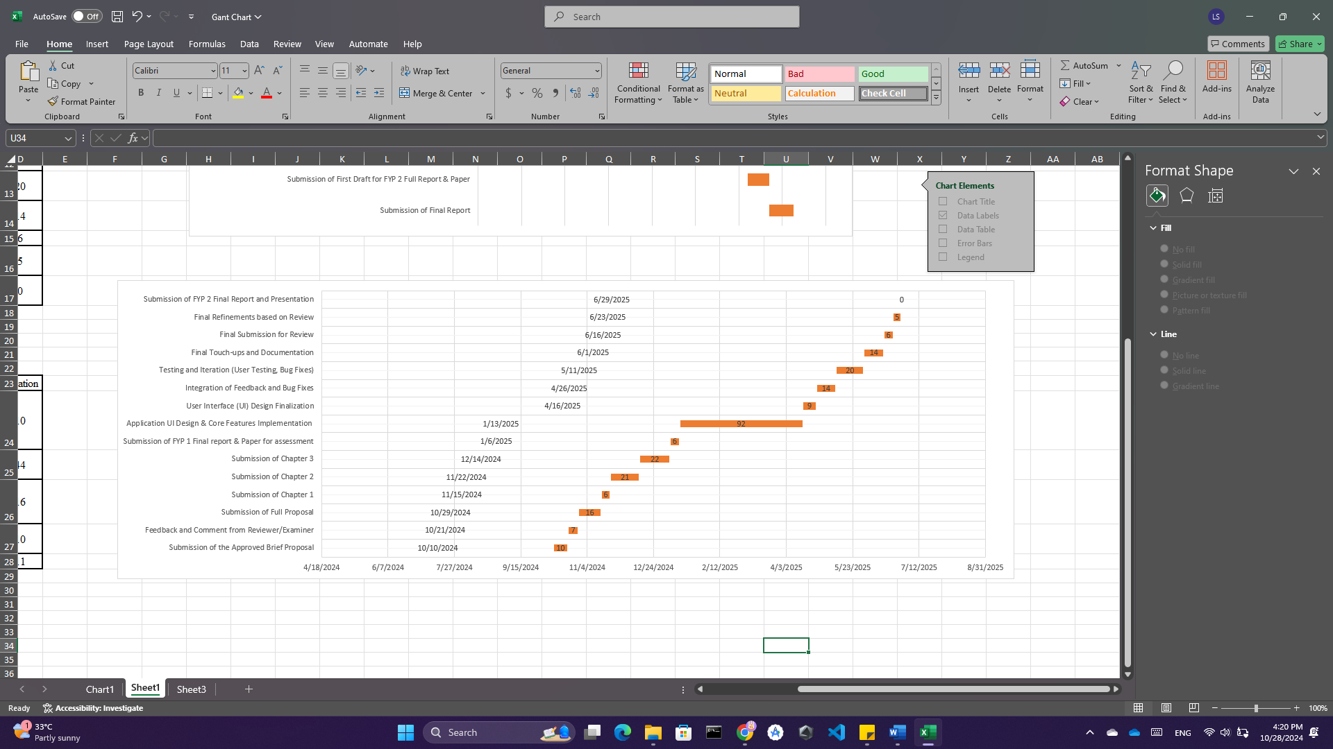
Figure 46: Gantt Chart for Project Schedule FYP 1 and FYP 2

Appendix C: Survey Questionnaire
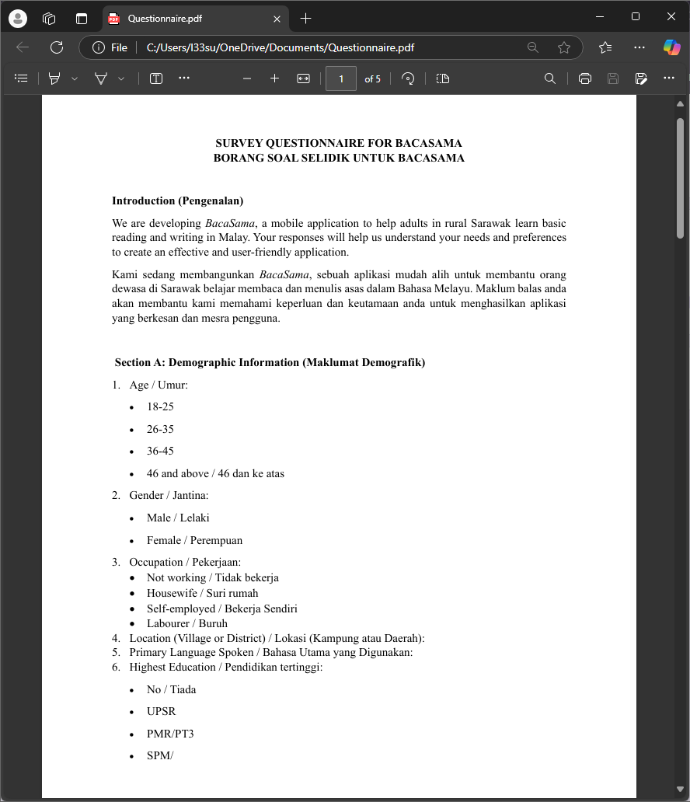
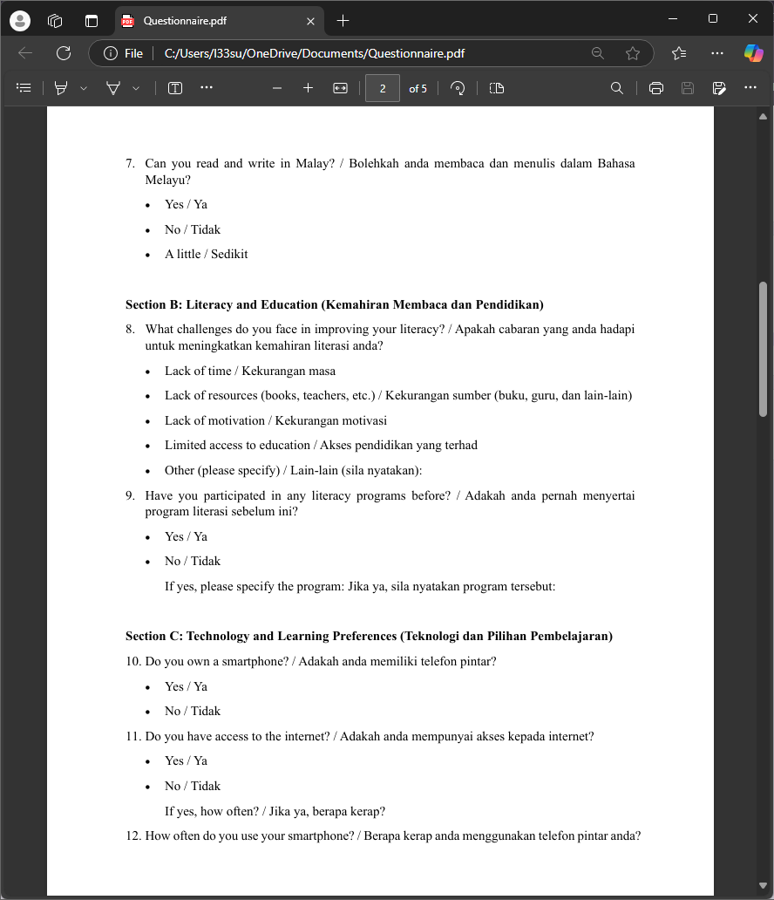
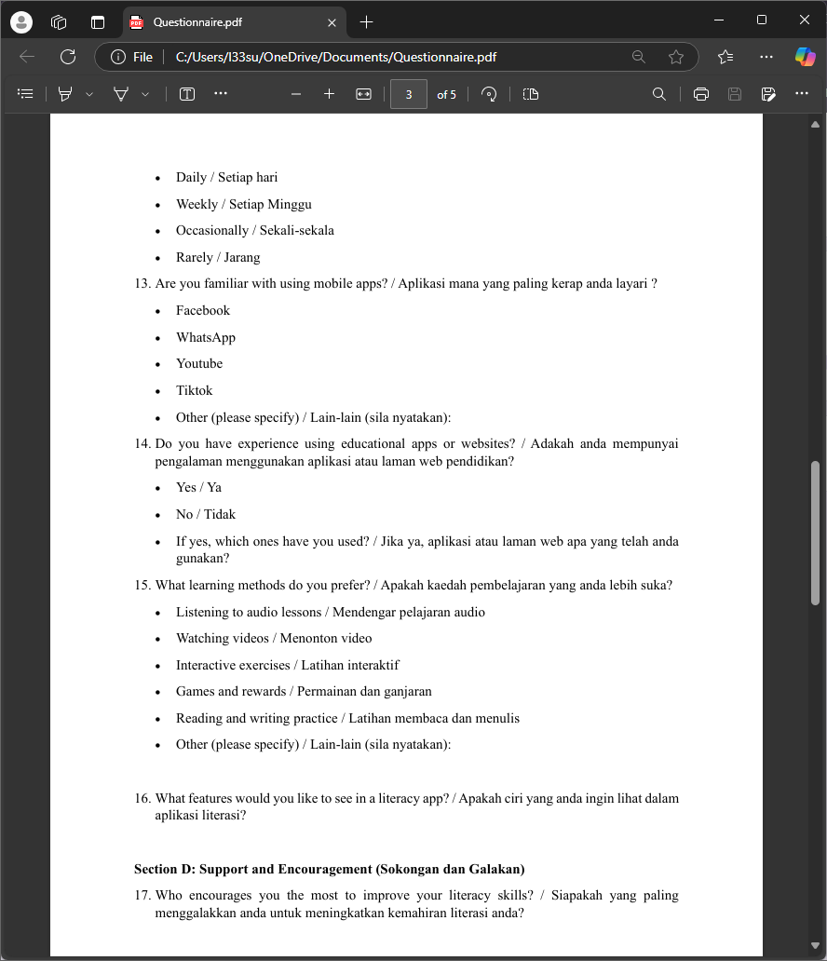
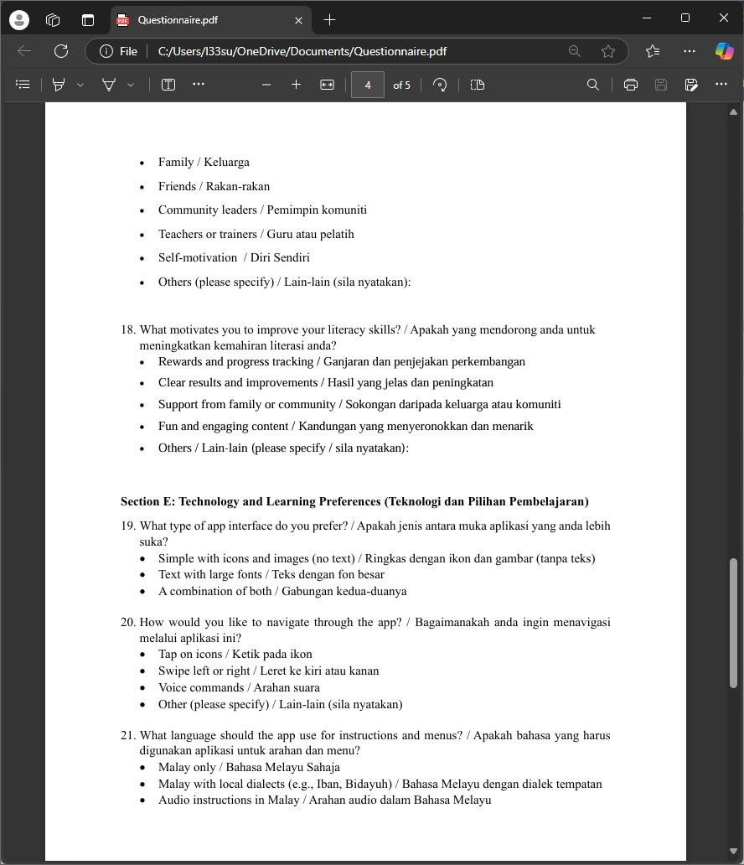
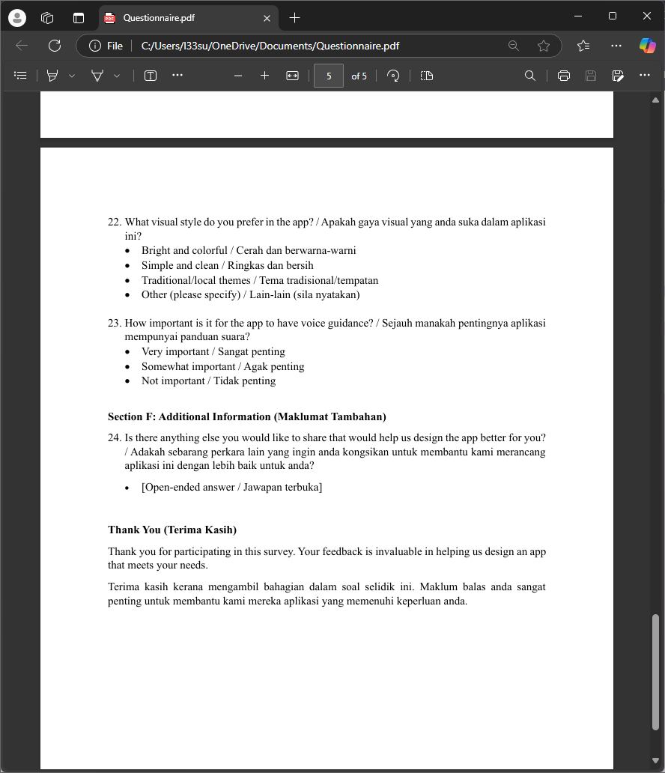

Appendix D: Component Diagram
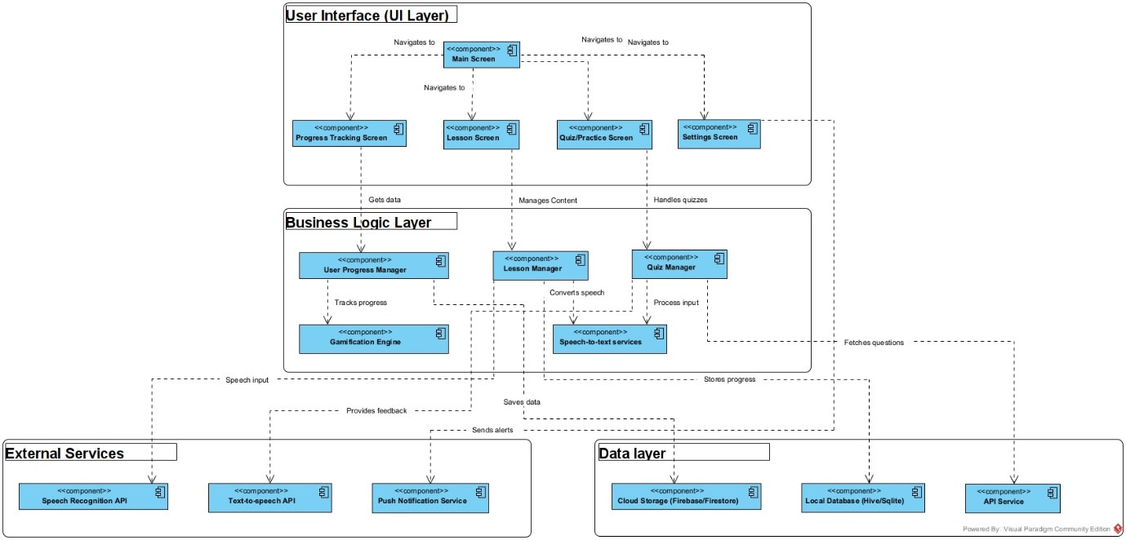
Figure 47: Component Diagram for BacaSama

